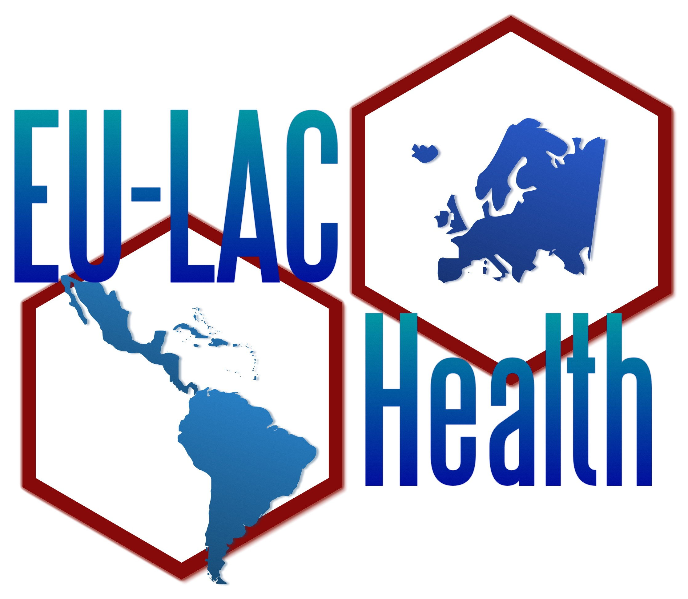 | 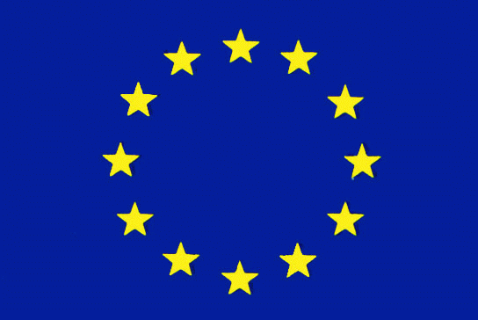 | 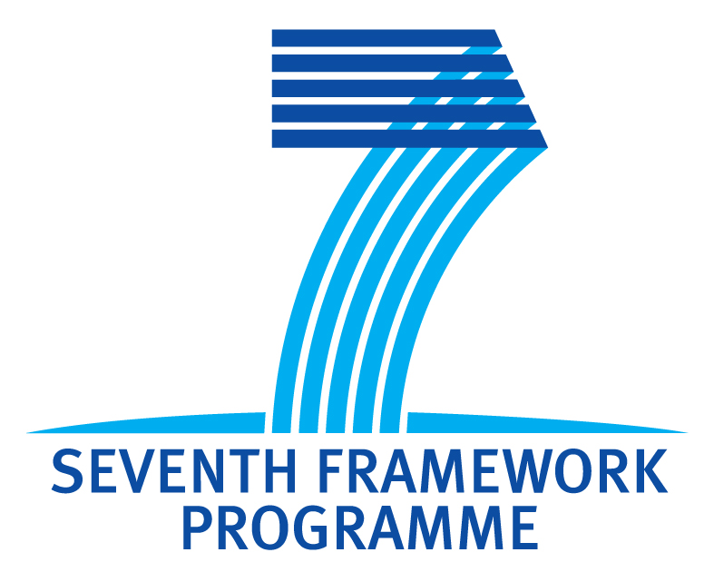

Defining a Roadmap for Cooperative Health Research between the EU and Latin America-Caribbean countries: a Policy-Oriented approach.

EU-LAC HEALTH

Work Package 1,
Integrated report

STATE OF PLAY

Prepared by
Council on Health Research for Development
(COHRED)

June 2012

The EU-LAC HEALTH project is co-funded with the support of the European Community's Seventh Framework Programme (FP7/2007-2013) under grant agreement nº 281459.
European Commission, FP7 Health Programme.

Summary 3

Introduction 4

1. An analysis of the existing political framework of S&T collaboration between EU and the LAC region 6
1.1 Coordination and management mechanism for EU-LAC relationship 6
1.2 Historical overview of the EU-LAC relationship in the field of Science and Technological cooperation 7

2. Latin American and Caribbean at a glance 10
2.1 Socioeconomic view 10
2.2 LAC investment in Science and Technology 12
2.3 Scientific production in the region 16

3. Health research systems in Latin America and the Caribbean 18
3.1 Governance and management of national health research systems 18
3.2 Financing for health research 19
3.3 Priorities in health research 19
3.4 Major actors in the national health research systems 20
3.5 Human resources for health research 20

4. Analysis of the present situation of R&D on health in the European Union 22
4.1 European Union’s investment in Research and Development 22
4.2 Scientific contribution of the EU in health related research 24
4.3 Health research systems in the European Union 26

5. Identification and analysis of the existing health research funding programmes 28
5.1 Public funding of health research in the European Union 28
5.2 Bilateral schemes between EU member countries and LAC countries 36
5.3 LAC regional and sub regional organisations 42

6. Conclusions 47

Bibliography 49

Summary

This report presents the situation of two different regions -European Union and Latin America and the Caribbean (LAC)- in relation to the structures, investments, funding, scientific production and country participation in the 7th Framework Programme of the EU. Differences between the regions’ development is known, and differences within regions are more severe in Latin America and the Caribbean.

There is a long history of cooperation and willingness to improve relations between the two regions. There is an established cooperation and political mechanism that allows regions to analyse, plan and implement actions towards a better and fruitful cooperation.

LAC has a population of close to 600 million people, of which half live in two countries, Brazil and Mexico. Even though health indicators have improved, it has not improved the same along the region, differences in health investments, fragmentation of health systems and specific countries’ issues have caused these to persist.

Investment in R&D in Latin America has increased mainly thanks to the big efforts Brazil has made, and four countries are the main producers of scientific papers and European Union (EU) Framework Programme 7 (FP7) participation. This programme has implemented several initiatives through which countries have developed projects towards strengthening Latin America’s and the Caribbean’s participation in FP7. The same four countries with the highest scientific output in the LAC region are the holders of bilateral agreements with the EU. These countries are Argentina, Brazil, Chile and Mexico.

Research for health systems is also a reflection of R&D investments and few countries have a structured research for heath system. Financing and linking it to research priorities is something that not all countries have been able to have in place. The well functioning Sectoral Funds to finance research for heath implemented in various countries with their own variations, is a mechanism that has allowed funding to flow and foster research.

In the European Union financing through FP7 - the main programme for research financing - devotes a significant amount to health. EU’s scientific production has increased as is well recognised. Through the FP7, the EU member states, associated countries and third countries have all benefited through one or more of the several programmes that have been implemented. LAC’s participation has grown. EU Transnational initiatives have played a key role in supporting cooperation.

While the EU’s efforts of unity and common market have resulted in a strong alliance and specific financing mechanisms, there is big division due to geopolitical and historical reasons that is reflected in the amount of organisations existing in the LAC region. This causes a great fragmentation and either duplication of efforts or issues that are not attended. This is to be noted as the region of the Americas has two of the oldest organisations in the world, the Organisation of American States (OAS) and the Pan-American Sanitary Bureau/ Pan-American Health Organisation.

EU-LAC Health is oriented to improve cooperative health research between Europe and Latin America-Caribbean countries by establishing (as part of the roadmap) new mechanisms (programmes, funding schemes, etc.) and facilitating the coordination of policies and funding.

This five year coordinated action proposes to define a detailed plan to guide policy makers and other stakeholders on future actions to achieve the above. This consensus roadmap will be developed using a policy-oriented approach and taking into account the new political framework for EU-LAC collaboration in S&T.

Introduction

This report summarises four task reports of Work Package 1 (WP1) and the comments gathered in a two day workshop (March 2012 – Brazil) of the Project “Defining a Roadmap for Cooperative Health Research between the EU and Latin America-Caribbean countries: a Policy-Oriented approach” (EU-LAC Health), co-financed by the 7th Framework Program of the European Union (EU).

The EU-LAC Health coordination action proposes to define a detailed plan to guide policy makers and other stakeholders on future actions to support cooperative health research between Latin America and Caribbean countries (LAC) and the European Commission and Member States (EU). This consensus Roadmap will be developed using a policy-oriented approach and taking into account the new political framework for EU-LAC collaboration in S&T. The Roadmap will support policy-makers and R&D funding bodies and provide them with new insights on how to best coordinate and fund cooperative health research between the two regions. An important effort will be devoted during the project in trying to link and coordinate two important policy areas with strong involvement in health research funding: Science and technology policy (research) and International development cooperation.

This report on the State of the Play analysis reflects the present political framework and current situation of EU-LAC cooperation in health research in the European Union and in the Latin America and the Caribbean regions. It has involved the examination of relevant written material and consultation with important stakeholders and experts to identify and analyse major issues affecting EU-LAC cooperation in health research. Work focused mainly on three important issues:

- Analysis of the existing framework of S&T collaboration between LAC and EU. A review of the existing political and economical framework of S&T collaboration between the EU (EC and member countries) and the LAC region was carried out.
- Analysis of the present situation and future needs of R&D on health in LAC and EU regions. An in-depth analysis of the actual situation of health research in the EU and LAC regions based mainly on deskwork and personal interviews is presented. The analysis focuses on the situation in the EU as a whole, member countries and Latin American and Caribbean countries. Main topics addressed are: Health research systems, health research funding, main actors, health research capacity and S&T priorities and future actions.
- Identification and analysis of existing health research funding programmes promoting EU-LAC collaboration. A review of all the cooperative health research programmes that fund S&T actions (including R&D projects, capacity building, technology transfer) between the EU and LAC partners was carried out. Main programs, funding agencies and participant countries were identified and analysed, including, when possible, the dedicated budgets and real costs of past years and future trends.

Together with desk analysis, one 2-day workshop to discuss the main findings and drawn conclusions on the State of Play was held in Brazil with participation of partners and members of the Advisory Committee. This workshop was also very useful to inform LAC policy makers and other stakeholders of the objectives and planned activities of the project.

This report is the final document of the above-mentioned actions and includes main findings of the analysis work and conclusions drawn at the workshop. Partners participating in its content through the elaboration of individual reports were: The Oswaldo Cruz Foundation (FIOCRUZ) from Brazil, the Agency for the Promotion of the European Research from Italy (APRE), the Carlos III Health Institute of Spain (ISCIII), and the Council on Health Research for Development (COHRED) Switzerland/Mexico.

We thank all those partners, advisory board members and participants to the workshop for their valuable comments that contributed with bringing fresh and unbiased perspectives.

1. An analysis of the existing political framework of S&T collaboration between EU and the LAC region

Knowledge about political and strategic framework of scientific and technical cooperation between Europe and Latin America allows us to have an adequate analysis of the relevance of the project. This view helps to adjust the project within the current framework, ensuring its sustainability.

1.1 Coordination and management mechanism for EU-LAC relationship
The EU-LAC bi-regional political dialogue is structured in three levels:

Senior Official Meetings (SOM)
EuroLat (Euro-Latin American Parliamentary Assembly)
Summits of Head of States
- On the bottom level, is the Euro-Latin American Parliamentary Assembly (EuroLat) established in Brussels in November 2006 after the Declaration of Cartagena of Indies in August 2005. It has been constituted as the parliamentary institution of the bi-regional strategic partnership between EU and LAC.
- On the second level, with a more executive nature, is the Senior Official Meetings (SOM), a series of high-level meetings aimed at improving the quality and quantity of bi-regional political dialogue.
- The Senior Officials Meeting (SOM) usually precedes the Summit of Heads of State, the highest level in decision-making.

The content and proposals that have fostered or oriented the work of the bi-regional summits arises primarily from the following communications of the European Commission and their subsequent conclusion of the Council of the European Union:
- “A stronger partnership between the European Union and Latin America”. COM (2005) 636 of 08.12.2005.
- “New perspectives on the European Research Area”. Commission Green Paper. April 2007.
- “A strategic European framework for international science and technology cooperation” COM (2008) 588 final.
- “Vision 2020 for a European Research Area” Council Conclusion about a definition of Competitiveness Council Meeting 2891st. Brussels. December 2008.
- “The European Union and Latin America: Global Players in Partnership” COM (2009) 495/3.
- “The EU Role on Global Health” Communication from the Commissions. March 2010. (COM 2010) 128 Final.
- “European Research Area’s social dimension”. Council Conclusion. Competitiveness Council Meeting. 3016th May 2010. Brussels.
- “Europe 2020, a strategy, for smart, sustainable and inclusive growth”. COM (2010) 2020 final. Brussels 3.3.2010.
All of them have been useful as a framework for promoting the scientific and technical cooperation in a more effective and accurate way.

1.2 Historical overview of the EU-LAC relationship in the field of Science and Technological cooperation

First Period: From 1970´s to 1986
Under European Economic Community
The objectives in the first years of the bilateral cooperation pursued to improve trade cooperation between MERCOSUR (Southern Common Market) and Europe, the support of Europe to the sub-regional integration, social cohesion and development aid.

Second period: From 1985 to 2007
Since the joining of Spain and Portugal to the EU, and up to the Lisbon Treaty
When Spain and Portugal joined the EU (then the European Economic Community) in 1986, a boost to increase cooperation between both regions took place.
The Lisbon Treaty introduced legal basis for the creation of the European Research Area. This area should allow, above all, the free movement of researchers, scientific knowledge and technology. During this period there were: Two Ministerial Summits, two Senior Official Meetings and four Heads of State and Government Summits.
It was in the Rio de Janeiro Summit in 1999 where the Heads of State and Government of both regions first met. It was also decided to create a bi-regional strategic partnership with a definition of priorities in order to act in a coordinated manner in political, social, scientific, cultural and economic areas. From the beginning, cooperation on knowledge and innovation were introduced into the agenda of political dialogue between the two regions at the highest level.
Two relevant SOM in the field of S&T were organized following the Rio Summit in order to prepare the next summit scheduled to take place in Madrid in 2002:
- Lisbon SOM on 5th and 6th June 2000: Scientific and technological cooperation was convened.
- Brasilia SOM on December 2001: The participants agreed on a shared vision for bi-regional S&T Cooperation and instruments defined to move forward a specific space for EULAC S&T Cooperation: EU LAC Knowledge Area.

Third period: From the Treaty of Lisbon to the Summit of Madrid, 2007-2010
During this period one S&T Ministerial Summit, one S&T Senior Officials Meeting and two Heads of State and Government Summits were held.
No doubt the sixth Summit in Madrid within the EU Presidency of Spain meant an important step forward in the promotion of the social dimension of the European Research Area concept. Its central theme was “Towards a new phase of the bi-regional association: innovation and technology for sustainable development and social inclusion”. One of the highlights of the Summit was the adoption of the EU-LAC Joint Initiative for Research and Innovation.
EU-LAC Joint Initiative for Research and Innovation is intended to make progress on the road to the EU-LAC Knowledge Area. It entails priorities for boosting bi-regional S&T cooperation and making high-level dialogue as a permanent feature of the relationship. In order to ease the implementation process and to secure the continuity of approved agreements, a permanent Senior Officers Meeting (SOM) with LAC and EU representatives should be established, with annual meetings and a more technical support structure.
The creation of a Joint Cooperation Fund as a working instrument was proposed under the JIRI (Joint Initiative for Research and Innovation). This Fund could support a broad range of activities and, apart from research; innovation and infrastructure should be considered.

Fourth period: From the Madrid Summit onwards.
The Europe 2020 Strategy, successor to the Lisbon strategy, aims at fostering smart, sustainable and inclusive growth.
At the level of EC, the objective is to complete the European Research Area and enhance joint programming with Member States and regions. In the case of LAC, the objective is to establish an EU LAC Knowledge Area through practice.
Two Science and Technology Senior Officials Meetings (Brussels, March 2011 and Santiago de Chile, April 29, 2011) took place in this period.
The first Senior Officials Meeting (SOM) was held in Brussels, March 2011. It established three thematic working groups, co-led by one country from each region. It was recommended that bi-regional cooperation should be supported by research and development policies at European level.
The EU-LAC SOM met again in Santiago, Chile, on April 2011, to monitor the agreements of the Sixth EU-LAC Summit held in Madrid in May 2010, and to advance preparation work for the Seventh Bi-regional EU-LAC Meeting, which will be held in Chile 26th and 27th of January 2013.
In March 2011, a roadmap was developed in a meeting held in Brussels. The key steps to implement the Joint Initiative were outlined and four bi-regional groups were defined: Mexico and Spain will coordinate the topic of Energy, Argentina and France the one on Bio-economics and food safety, Chile and Finland the one on ITC to face society threats, and Colombia and Spain on Biodiversity and climate change. These four groups will identify areas for bi-regional cooperation and ideas for initiatives and pilot projects.

In this meeting and coming actions, under the EU-LAC Joint Initiative for Research and Innovation, endorsed by the Madrid Summit, aims at developing the "EU-LAC Knowledge Area" through: i) improving cooperation in research and innovation; ii) strengthening scientific and technological capacities, and infrastructures; iii) to enable sustainable research, innovation and knowledge sharing taking into account the contribution of ancestral and traditional knowledge; iv) to boost the use of new technologies and technology transfer underpinning sustainable socio-economic development and v) to foster cooperation between both regions as regards the digital economy and the reduction of the digital divide for improving competitiveness while making social inclusion a cross-cutting issue.

The EU-LAC Health coordination action proposes to define a detailed plan to guide policy makers and other stakeholders on future actions to support cooperative health research between Latin America and Caribbean countries (LAC) and the European Commission and Member States (EU). This consensus Roadmap will be developed using a policy-oriented approach and taking into account the new political framework for EU-LAC collaboration in S&T. The project will build on the framing of the EU-LAC relationships related to research on the most recent agreements.

2. Latin American and Caribbean at a glance

2.1 Socioeconomic view

The Latin American region is composed of the Spanish, Portuguese and French speaking countries of the Americas; Haiti shares the Island with the Dominican Republic, therefore geographically, Cuba, Haiti and the Dominican Republic are located in the Caribbean. The rest of the islands in the Caribbean compose the English speaking Caribbean. The countries in the region share history and cultural similitudes as they all were under Spanish, Portuguese, French or British domain before gaining independence. In the Caribbean there are still territories and protectorates and countries with population as small as 1,424 in Saba, a territory of the Netherlands, while in the continental region, Brazil has the largest population with over 190 million inhabitants.

LAC is in a demographic transition period due to low fertility rates (it is among the lowest in the world) and the decrease in mortality rates. Life expectancy has increased in 7 years in the past quarter century, therefore the average age now exceeds 70 years.

Table 1 lists key indicators that show the differences amongst countries of the region. The total number of population for the region is close to 600 million inhabitants, 575 million living in Latin America. Life expectancy is of 74.7 years, while country ranges go between 62.5 for Haiti and 79.6 for the United States Virgin Islands.
This continent is also undergoing a process of epidemiological transition. Without underestimating the disease burden (DALYs-Disability Adjusted Life Years) (1) attributable to communicable diseases (27%), at present the non-communicable diseases (chronic degenerative diseases and mental disorders) are first on the list with 54%. Outstanding as well are the problems arising from accidents, injuries and violence, which represent 19%, a number much higher than the figures observed in other parts of the world.
It is estimated that more than 20 million Latin Americans and Caribbean’s are now living abroad, especially in the U.S. and Spain. Young people between 10 and 24 represent 28% of the population in LA and the Caribbean (161 million).
The region had a Gross Domestic Product (GDP) growth in 2010 of 5.9%; Latin America had a growth of 6.0%, while the Caribbean had just 0.2%. There were countries in the Caribbean with a negative growth of -7.9% (Antigua and Barbuda). The country with the highest growth was Paraguay (15%) in Latin America, while in the Caribbean was the Dominican Republic with 7.8%.

The region is one of contrasts, while there are important differences between countries, variations inside the countries are also important. It is a region that has one of the wealthiest men on earth while his country has over 50% of poor people. This phenomenon is replicated in many countries in the region – wealth is unevenly distributed. One of the most prominent features of the region is its heterogeneity, both between the countries as well as internally.

The Human Development Index (HDI, prepared by the United Nations Development Program) shows that Chile was the country that had the best index of the region (0.798) in 2009. In that
Table 1. Latin American and Caribbean key indicators, CEPAL, 2011
Countries and Regions | Population 2010/1000 | Life expectancy, both sexes, 2010 | Annual growth rate, GDP 2010 | % of GDP in health, current prices, 2010 | Infant Mortality rate, 2005 | Maternal Mortality rate, 2008/1,00 live births
Anguilla | 15 | ... | ... | ... | ... | ...
Antigua and Barbuda | 89 | ... | - 7.9 | ... | … | ...
Netherlands Antilles | 201 | 76.8 | ... | ... | 12.8 | ...
Argentina | 40 738 | 76.2 | 9.2 | 6.2 | 13.4 | 70
Aruba | 107 | 75.5 | ... | 9.6 | 15.5
Bahamas | 343 | 75.9 | 0.9 | 2.3 | 9.0 | 49
Barbados | 273 | 77.1 | 0.2 | 2.9 | 10.1 | 64
Belize | 312 | 76.3 | 2.9 | ... | 16.7 | 94
Bolivia | 10 031 | 67.2 | 4.1 | 1.9 | 45.6 | 180
Brazil | 195 498 | 73.5 | 7.5 | ... | 23.6 | 58
Chile | 17 133 | 79.1 | 5.2 | 4.1 | 7.2 | 26
Colombia | 46 299 | 73.9 | 4.3 | 2.2 | 19.1 | 85
Costa Rica | 4 639 | 79.4 | 4.2 | 6.6 | 9.9 | 44
Cuba | 11 203 | 79.1 | 2.1 | 10.6 | 5.1 | 53
Dominica | 68 | ... | 0.9 | ... | ... | …
Ecuador | 13 773 | 75.8 | 3.6 | ... | 21.1 | 140
El Salvador | 6 192 | 72.1 | 1.4 | 4.1 | 21.5 | 11
Grenada | 104 | 76.2 | 0.0 | 2.8 | 13.4 | …
Guatemala | 14 376 | 71.4 | 2.8 | 1.4 | 30.1 | 110
Guyana | 754 | 70.3 | 4.4 | 9.9 | 42.4 | 270
Haiti | 10 089 | 62.5 | - 5.1 | ... | 48.8 | 300
Honduras | 7 621 | 73.1 | 2.8 | ... | 28.2 | 110
Cayman Islands | 56 | ... | ... | ... | ... | ...
Turks and Caicos Islands | 38 | ... | ... | ... | ... | ...
British Virgin Islands | 23 | ... | v | ... | ... | ...
United States Virgin Islands | 109 | 79.6 |  | ... | 9.1 | ...
Jamaica | 2 741 | 73.5 | - 1.3 | ... | 23.3 | 89
Mexico | 110 675 | 77.2 | 5.6 | 3.1 | 16.7 | 85
Montserrat | 6 | ... | ... | ... | ... | ...
Nicaragua | 5 822 | 74.5 | 4.5 | ... | 21.5 | 100
Panama | 3 508 | 76.3 | 7.6 | 2.2 | 18.2 | 71
Paraguay | 6 460 | 72.8 | 15.0 | 3.4 | 32.0 | 95
Peru | 29 495 | 74.1 | 8.8 | 1.1 | 21.2 | 98
Puerto Rico | 3 749 | 79.3 | ... | 1.6 | 7.2 | 18
Dominican Republic | 9 899 | 73.2 | 7.8 | 2.4 | 29.6 | 100
Saint Kitts and Nevis | 52 | ... | - 2.4 | 4.0 | ... | …
St Vincent and the Grenadines | 109 | 72.6 | - 2.8 | ... | 23.3 | …
Saint Lucia | 174 | 74.9 | 3.2 | ... | 12.6 | …
Suriname | 525 | 70.9 | 7.3 | 2.5 | 22.2 | 100
Trinidad and Tobago | 1 341 | 70.4 | 0.0 | ... | 26.0 | 55
Uruguay | 3 372 | 77.1 | 8.5 | 5.1 | 13.1 | 27
Venezuela | 29 043 | 74.7 | - 1.5 | ... | 17.0 | 68
Latin America and the Caribbean | 590 082 | 74.7 | 5.9 |  | 21.8 | 85
Latin America | 575 867 | 74.6 | 6.0 |  | 21.7
The Caribbean | 41 646 | 72.7 | 0.2 |  | 34.5
Source: CEPAL 2011 Anuario estadístico de América Latina y el Caribe, http://websie.eclac.cl/anuario_estadistico/anuario_2011/esp/content_es.asp
year, the average of the region´s HDI was 0.722. Argentina, Uruguay, Cuba, Mexico, Panama and Costa Rica all had an HDI above the regional average.

According to the World Bank, in 2005, 8% of Latin Americans lived on less than US$ 1.25 per day and 45 million people lived below the poverty line - these indicators have not changed significantly. Table 2 shows a series of indicators that demonstrate the differences between countries in the region. On the other hand, at the same time in which, in 2009, Brazil had the highest GDP of the region, a quarter of its population lived in a state of poverty and 7% in a situation of extreme poverty, which also demonstrates the great internal inequality of a Latin American country.

Countries in the LAC region face big challenges regarding their health system. Most of the systems are fragmented. Even with the efforts towards universal health coverage, the systems face regulated or unregulated health systems mixing public services, through Ministries of Health or Social Security agencies, private services, or mixtures of these, or are run by insurers as in Chile and Colombia.

2.2 LAC investment in Science and Technology

Five countries are responsible for 80% of the GDP of the region – Brazil, Mexico, Argentina, Venezuela and Colombia (Figure 1). This concentration draws attention to the need for different development strategies, which in turn will impact the type policies on science, technology and innovation adopted for each country in the region.

Figure 1 . Distribution of GNP (in PPP in US$ billion) in Latin America, 2009.

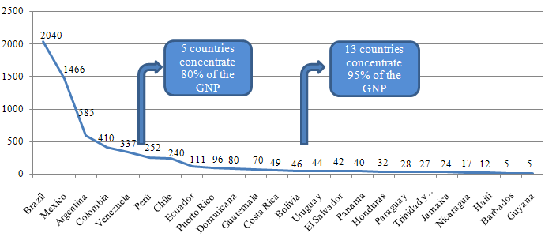
Source: RICYT, 2012. Indicators. Gross National Product. PPP = Parity Purchase Power.

Table 2 . Relevant aspects regarding scientific research in evaluated countries

In 2009, Brazil was the LAC country that invested most in R&D as a percentage of GDP, with 1.18%, while the average of the region was 0.69%. For comparison, in the Ibero-American region this figure was 0.88% (Figure 2). Overall, despite the financial crisis of 2008, there was no reduction of investment in R&D in the region, taking into account the years of 2005 and 2009.

Figure 2. Investments in R&D with regard to GDP (%). Selected regions and countries, 2009.
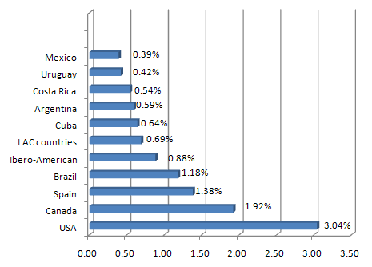
Source: RICYT, 2012. Indicators. Expenditure on S&T in relation to the GDP. Expenditure on R&D.

In 2005, Brazil accounted for over half of the investment in R&D in the region. Together with the investments of Mexico and Argentina, it represented 89.7% of the investment of the whole region. The sum of the investments in R&D of the rest of the LAC countries surpassed only the effort of Argentina. In 2009, Brazil increased its investment by 18% reaching 70.4% of the total of the LAC, while Mexico reduced its contribution by half (Figure 3). The investments in R&D in the LAC rose from US$14.4 million in 2005 to US$ 26.9 million in 2009. For purposes of comparison these investments accounted for only half of those made by the Ibero-American region (U$ 28.6 million (2005) and US$ 51 million (2009)).

Figure 3 . Distribution of the investment in R&D in millions of US$ in the LAC
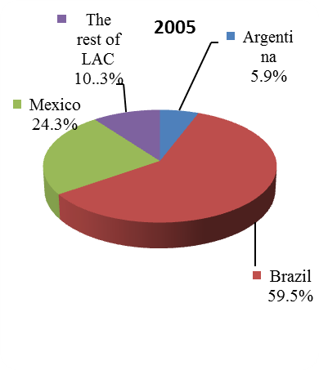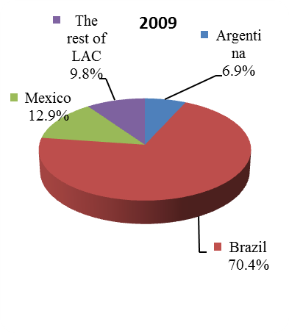
Source: RICYT, 2012. Indicators. Expenditure on Science and Technology.

Figure 4 shows the correlation between the density of R&D and researchers for some outstanding countries and regions. On the left one can find the new-comer, Brazil. The intensity of R&D of this country may be small, but its contribution to the global storehouse of knowledge is growing rapidly.

Figure 4 . Global Investment in R&D in absolute and relative term, 2007. Selected countries and regions.
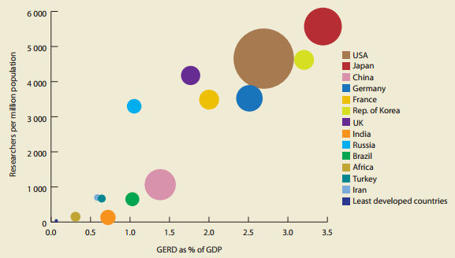
Note: The size of the circle reflects the size of the gross domestic expenditure in R&D for the country or group.
Source: UNI-MERIT based on data from the UNESCO Institute for Statistics and the World Bank, and UNESCO, 2010.

In 2007, the world had 7,209 million researchers. Latin America and the Caribbean had 252 thousand researchers, equivalent to 3.5% of the global ration (Figure 5). In absolute terms, Brazil had 124.9 thousand (1.7% of the overall total of researchers), Argentina 38.7 thousand and Mexico 37.9 thousand (both with 0.5%). If we consider the number of researchers per million inhabitants, Argentina had 980 researchers, Brazil 657 and Mexico 353, while the average in the LAC region was 443 in 2007. In that same year, the number of researchers in the EU accounted for 20% of the world total. The number of researchers per million inhabitants in the EU was 2,936 - seven times more than the average of the LAC.

Figure 5. Location of Researchers in the principal countries and regions selected. 2002 and 2007 (in %)
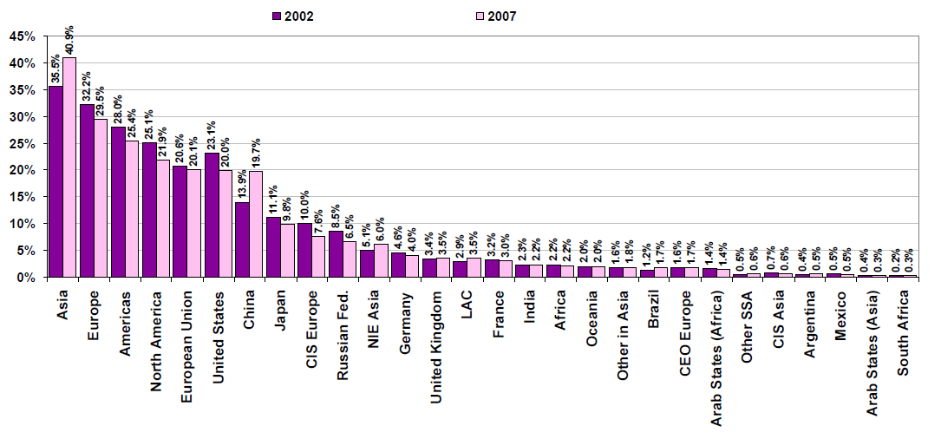
Source: Human Resources in R&D – UNESCO Institute for Statistics, 2010

Of all the indicators used here, that of patents is the one that more decisively points to the inequality in the generation of knowledge at a global level. US dominance in the world share of patents of the US Patents and Trademarks Office (USPTO) is outstanding, with 52%. In the year 2007, the EU contributed with 15.2% of global patents (a 13% decrease compared to the year 2002). The participation of Germany if contrasted with patent-holding countries of the EU was 41%. In that same year, the participation of the LAC was only 0.2% (in 2002 this fraction corresponded to 0.3%) of all patents registered in the US office of patents and trademarks.

2.3 Scientific production in the region

The investments in R&D have a direct relationship to scientific production. Among bibliometric indicators, the Thomson Reuters Science Citation Index (SCI) (Figure 6) was chosen, since it is most frequently used to measure scientific output. It allows comparisons both at the aggregate-level and in more detailed science-related areas, such as health.

Figure 6. Publication by area of health sciences: Biology, Biomedical Research and Clinical Medicine.
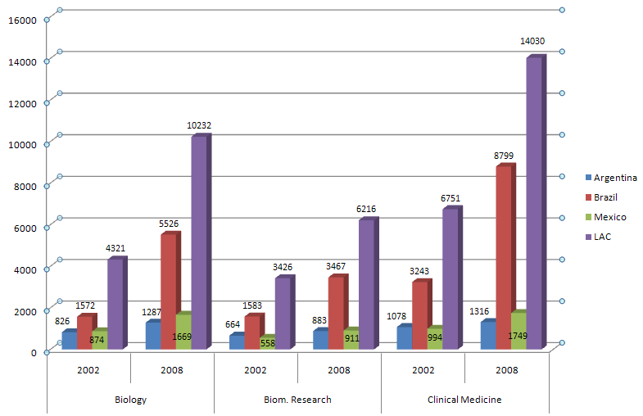
Source: UNESCO, 2010.

The growth of scientific production has a relation to the investment in science, technology, research and innovation. Using SCIMAGO data, and as shown in Figure 7, using a logarithmic scale as to show the differences, we can see that Brazil is the main producer in terms of publications with 81,230, followed by Mexico with 22,441, Argentina with 18,504. Between less than 10,000 and 5,000 are Cuba and Colombia, less than 5,000 and more than a 1,000 are Venezuela, Peru, Puerto Rico, Uruguay, and Jamaica. The rest have less than 1,000 publications.

Figure 7. LAC publications in Medicine/Public Health, 15 countries, 2010.
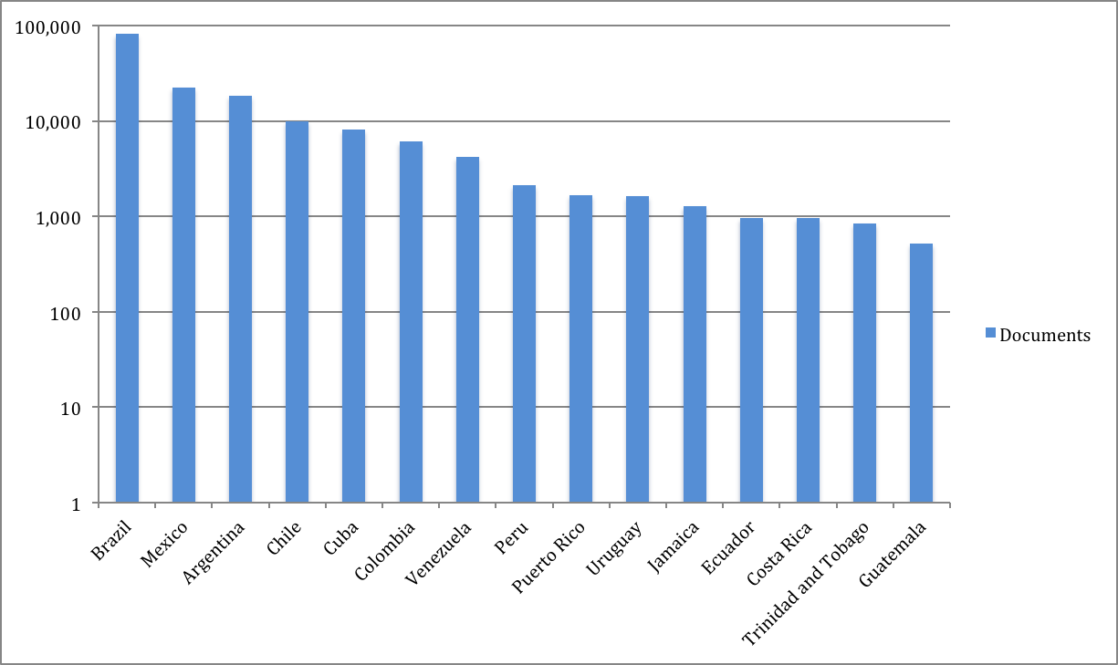
Source: http://www.scimagojr.com
In Figure 8, it is interesting to see the growth the main four countries have had from 1996 to 2010. It is clear that investment in science and technology in Brazil has paid off, while the other four countries have had a slower growing rate. Even though Argentina has a larger investment in R&D, it has a lower production than Mexico. This might be related to the amount of research institutions and collaborative efforts. In this period, Brazil has launched many new journals, which also provide a platform for local researchers to publish their work. These are peer-reviewed journals that have achieved a good quality and are indexed.

Figure 8. Comparative publication growth of 4
countries in Medicine/Public Health, 1996-2010, SCIMAGO.
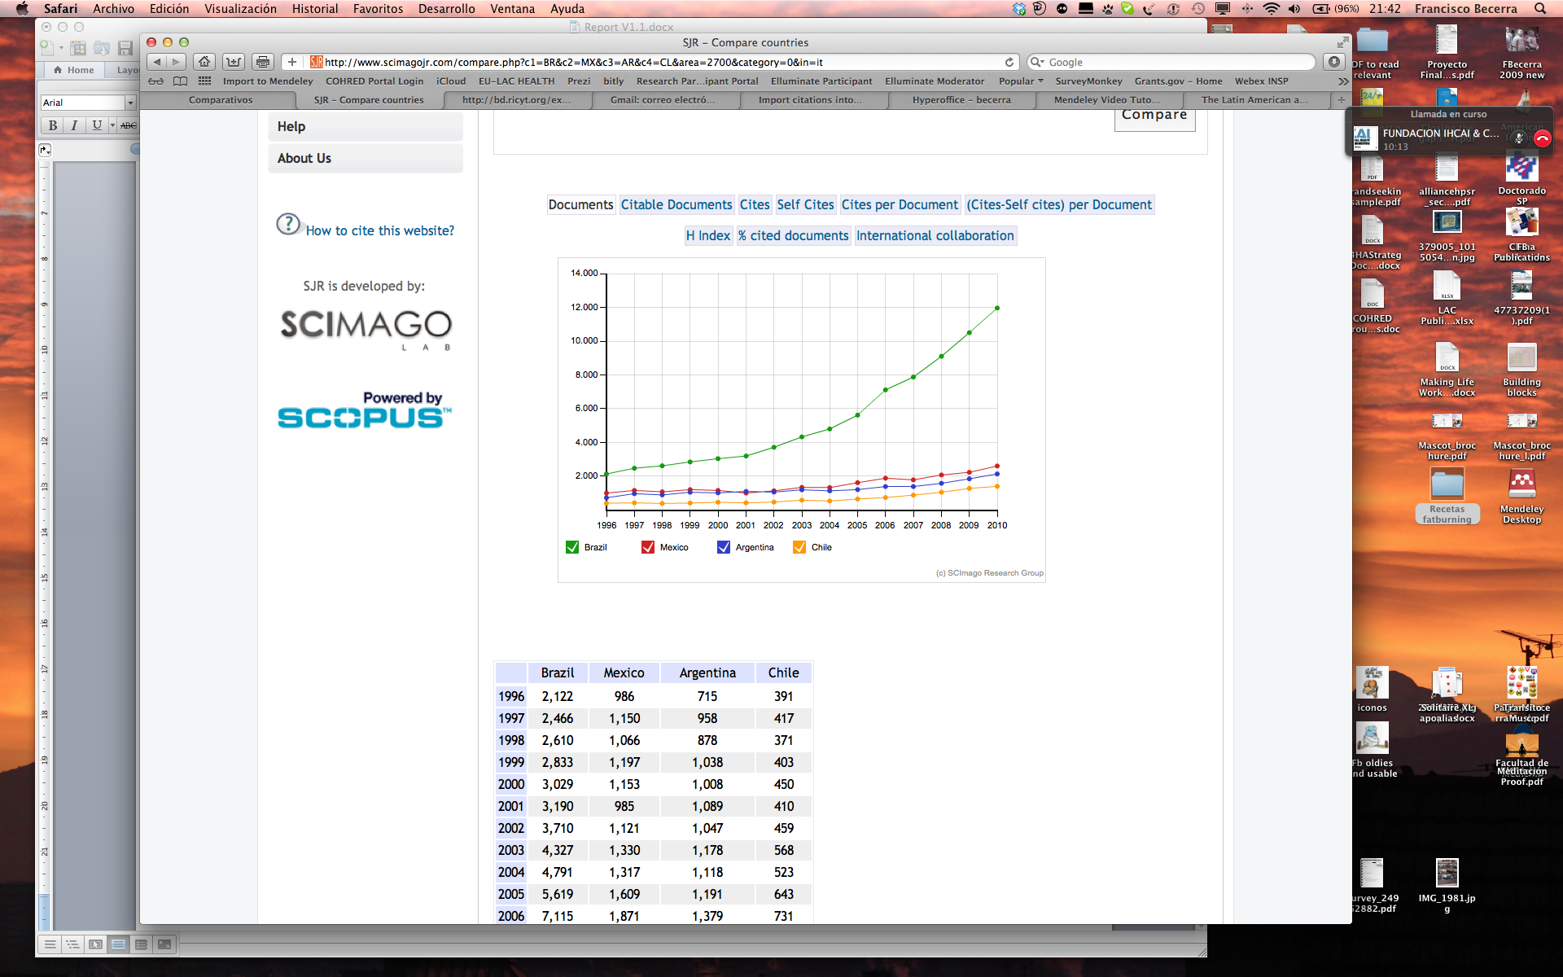
Regarding patents, Brazil, Mexico and Argentina are the countries that have the largest number of patents. The three countries have 81% of these from the LAC countries, but only represent 0.27% of the ones registered at the United States Patent and Trademark Office, and 0.33% at the European Patent Office.

3. Health research systems in Latin America and the Caribbean

An analysis of the National Health Research Systems (NHRS) of Latin American and the Caribbean was carried between November 2011 and February 2012. It was based on the answers provided to questionnaires that were delivered to the legal representatives of Latin American and Caribbean countries of the Ibero-American Ministerial Network for Health Education and Research (RIMAIS) so they could answer questions regarding their NHRS. Whenever necessary, the information was complemented with deskwork.

Thirteen out of 15 questionnaires distributed were received with descriptions of NHRS’s, twelve coming from countries (Argentina, Brazil, Costa Rica, Ecuador, Guatemala, Honduras, Mexico, Panama, Paraguay, Peru, the Dominican Republic and Uruguay) and one regarding the situation of the English speaking Caribbean. It should be mentioned that, although representatives put in great effort to answer the questionnaire, most reports had large gaps of information.

Health research systems have been defined as “the people, institutions, and activities whose primary purpose in relation to research is to generate high-quality knowledge that can be used to promote, restore, and/or maintain the health status of populations”

3.1 Governance and management of national health research systems

Many countries in Latin America have a formal governance body dedicated to health research. The Health and Science and Technology Sectors usually share this governance. The health sector is often responsible for clinical and public health research and is more in contact with the country’s health policy. The sector of science and technology is frequently responsible for biomedical research. It is common for both sectors to have their own management structures and priorities for health research. The degree of coordination between the two areas — which is crucial for a National Health Research System — varied between the evaluated countries. Mostly, the coordination between the two fields takes place through the participation of a representative of the Health sector in the sectorial group “health” within the S&T sector.

The development and consolidation of National Health Research Systems in the region gained momentum in the second half of the last decade. Many countries in the region implemented a specific policy, such as Peru, or are in the process of implementation, such as Paraguay. Others are discussing and approving such policies, such as Costa Rica and the Dominican Republic. Argentina, Guatemala and Uruguay, however, have no specific policies. Nonetheless, all evaluated countries have laws and regulations for clinical studies, ethical standards for research and product registries.

Finally, it was observed that Panama and Uruguay do not have clear governance schemes for health research. In these countries, actors operate independently, there is no coordination between them and it cannot be said that there is a Health Research System. For the countries in the Caribbean, research for health is under the mandate of the Caribbean Health Research Council that supports all English speaking Caribbean countries in the matter of research for health.

3.2 Financing for health research

Internally, countries investments in research for health is a reflection of the overall investment in Sc&T. Financing in the region for research for health is mostly by governments through public funds. Few countries have established sustainable mechanisms to secure financing for research. Argentina, Brazil, Chile, Mexico and Uruguay finance research through sectoral funds, an innovative way of securing funds for research, which is linked to specific topics in each call and ensures the sustainability of the fund for the life of the project.

The example of the Sectoral Funds from the above mentioned countries is something that other countries in the region should follow as a way to increase secure funding. This has been suggested in the reports of the 1st and 2nd Latin American Conferences on Research and Innovation for Health.

Other countries finance research through IDB (Inter-American Development Bank) loans that supports these actions. The main financers in the region are the Ministries or Councils of Science and Technology through various programmes. The good thing about the Sectoral Funds is that these break the dependency on annual budgetary issues, as the case of Brazil and Mexico. In the case of Mexico funds from CONACYT, the Ministry of Health and the two other main health care institutions, place their funds in a trust that is under the coordination of a Committee that is oversee by the auditing authorities. Funds are labelled and secured, and the project receives quarterly instalments. Funds generate interests that go to the main account.

3.3 Priorities in health research

Among the countries that contributed to this evaluation, Dominican Republic, Honduras, Panama, Mexico and Uruguay informed that they had not established any priorities for health research. The priorities defined for health research by the other countries were often established through similar processes, that is, by consulting with specialists in the fields of health, education, science and technology. For instance, in 2008, the Ministry of Public Health and Social Welfare in Paraguay, published the National Agenda of Priorities in Health Research.

In Argentina, both the Ministry of Health (MSAL) and the Ministry of Science and Technology (MINCyT), established priorities for health research. Around 200 representatives of governmental institutions, universities and both public and private companies were consulted to develop the plan. The MSAL’s agenda of priorities for health research was, in turn, the product of a discussion between decision makers within the Ministry (national programs and divisions) and a group of specialists that coordinate the annual open calls of the National Commission “Salud Investiga”.

In Peru, in 2009, the National Institute of Health (INS) of the Ministry of Health carried out a decentralized analysis to establish regional and national health research priorities. The goal was to promote efficient interventions in public health — which should be based on scientific evidence, cost-efficient, effective, equitable and significant. The process resulted in the establishment of five priorities for health research and seven national priorities for the health field.

In 2011, the Ministry of Health of Brazil launched the document “Strategic Research for the Health System” (PESS, in Portuguese) and redefined research priorities, which had been focused in the coordination with the scientific community. The new document clearly related priorities to goals in the National Health Policy. Brazil should be highlighted because it distances itself from the tendency – both internally and from Latin America – of the participatory process of priority setting in health research.

In Costa Rica, the establishment of the agenda of priorities for health research is the responsibility of the Division of Scientific and Technological Development in Health of the Ministry of Health. The Division is currently developing the National Plan of Science and Technology in Health with the participation of the major actors in the National System of Research and Technological Development in Health.

In Ecuador, at first, the process of establishing priority lines of health research was done through questionnaires sent by the Ministry of Health to health-related entities, both public and private, and NGOs, among others. Finally, at a national workshop with the provincial researchers a document was settled with the national priorities for health research.

The Caribbean Health Research Council, established its health research priorities for each “Program Area of Caribbean Cooperation in Health” — 3rd edition (CCH III, 2010-2015). CCH III determined the health priorities for CARICOM (Caribbean Community) member countries; priorities which comprehended eight areas that should be adopted (or adapted) by each country individually. To achieve a consensus about those eight areas, the Council consulted with many stakeholders such as Ministries of Health, Regional Health Institutes, Universities, NGOs and other institutions of the Caribbean’s 17 countries.

More recently and generally speaking, it was observed that Latin American countries have sought to establish priorities for health research based on their National Health Plans, which is the case of Paraguay, Brazil, Peru and Guatemala. However priorities of a two countries (Argentina and Costa Rica), were established by two different areas working in common: Health and Science & Technology.

3.4 Major actors in the national health research systems

The main actors in research for health in the countries in the region are a mix between governmental institutions, public and private universities and in some cases, the private sector. As to the implementation of research projects, public universities are, in general, the main actors, but specialized institutes of the ministries of health play an important role.

Few countries mentioned having information on the financing of health research. Brazil and Argentina, two of the major investors in Science and Technology in Latin America, both register information on their investments in S&T, as well as keep a registry of researchers, research institutions, etc.

The only sub-regional agency working for research for health and financing research through a prioritised agenda is the Caribbean Health Research Council, based in Trinidad & Tobago.

3.5 Human resources for health research

Argentina, Brazil and Mexico were the only countries that reported having more consistent policies and actions regarding human resources for health research. Generally speaking, the three countries have a registry of researchers, stimulate science careers, and evaluate the performance of researchers, among other actions to consolidate their National Health Research Systems.

One of the strategies of Brazil’s Policy on Science, Technology and Innovation in Health is the training and the incorporation of human resources from the least developed regions as the country seeks to decrease regional inequalities in the national scientific and technological production.

As to the other countries, although there has been an effort in that direction, only isolated actions were reported (such as incentive for scientific production, for instance), which do not make up a systematic set of activities in the area.

4. Analysis of the present situation of R&D on health in the European Union

An analysis of the actual situation of research for health in the EU was performed mainly through deskwork. Analysis focused on the situation in the European Union as a whole with a reference to individual member states where data was available. Close collaboration with related EU projects was sought in order to share information and data on the present situation of EU R&D on health.

4.1 European Union’s investment in Research and Development

Research, education and talent are crucial components for growth and innovation. However, there are large disparities between EU Member States and regions in terms of expenditure on research and development.

Huge differences in R&D intensity: the EU average investment in R&D as percentage of GDP is around 1.8%. Only Sweden and Finland are above the 3% target, seen as a level of investment in R&D necessary for Europe to remain competitive and contribute to the EU2020 strategy for a smarter, more sustainable and more inclusive growth for Europe. Austria, Denmark and Germany follow with a 2.5% investment. The rest of the countries fall below that, with the Slovak Republic and Cyprus with the smallest investments (0.6 and 0.4%).

Distribution of research activity across European regions

To reach the Europe 2020 objective of smart growth, the full innovation potential of EU regions needs to be mobilised. Innovation is important for all regions as to allow advanced ones to remain ahead and lagging ones to catch up.

Ten per cent of European regions that reach the ‘Europe 2020 strategy’ target of spending 3% or more of their GDP on R&D. These regions are also the ones that consequently generate 40% of the EU’s total R&D expenditure. This analysis also shows that Europe has a number of major scientific clusters that are strong, competitive, visible and attractive at the world level.

Twenty-five European regions account for more than 42% of the European publications in basic biology and in medical research. Six regions offer strong specialisation in medical research with the London and Paris regions alone providing 2.2% and 1.67% of the world medical research publications respectively. The world share of publications has decreased for most of the European regions with only four regions not showing a reduction of their relative weight when all research fields are included. Biomedical research presents a more favourable situation with seven regions increasing their relative weight between 2003 and 2008.

However, there are barriers to research, as local regulations, lack of harmonised policies, countries’ interests, national legislation and interpretation of EU legislation by member countries do cause serious gaps.

European Union investment in research and development for health

Recent data available on national investments in R&D for health as a percentage of GDP show there is an extremely wide variation in how much is invested among European countries, from just over 1% of Iceland or Switzerland to the low values of Portugal (0,1%) and Greece (0.05%).

There is no formal target for investments in R&D for health as a percentage of GDP. Several countries (Denmark, Iceland, Sweden, Switzerland, UK) invested 0.5% of GDP or more in R&D for health in 2005. If the other large economies with 2005 GDPs of US$ 1 trillion or more were to increase their investments in R&D for health to 0.5% of their 2005 GDP, this would raise the net annual level of financing for R&D for health by US$ 23 billion and a significant fraction of this increase could be devoted to problems relevant to the health needs of Low Middle Income Countries (LMIC).

Another indicator of how much governments support R&D in health in Europe is the so-called Government Budget Appropriations or Outlays on R&D (GBAORD). GBAORD data measure government support to R&D activities, or, in other words, how much priority Governments place on the public funding of R&D. It refers to budget provisions, not to actual expenditure. Unless otherwise stated, data include both current and capital expenditure and do not only cover government-financed R&D performed in government establishments, but also government-financed R&D performed in the business enterprise, private non-profit and higher education sectors, as well as abroad.

GBAORD data are covering all public budget spending related to R&D and are linked to policy issues by means of a classification by "objectives" or "goals". Latest data available from EUROSTAT reflect the total GBAORD by NABS 2007 socio-economic objectives, including a specific chapter for health. This chapter includes R&D related to protecting, promoting and restoring human health – broadly interpreted to include health aspects of nutrition and food hygiene. It ranges from preventative medicine, including all aspects of medical and surgical treatment, both for individuals and groups, and the provision of hospital and home care, to social medicine and paediatric and geriatric research.
This chapter also includes R&D related to:

- Prevention, surveillance and control of communicable and non-communicable diseases;
- Monitoring the health situation;
- Health promotion;
- Occupational health;
- Public health legislation and regulations;
- Public health management;
- Specific public health services;
- Personal health care for vulnerable and high risk populations.

GBAORD values for health in Europe in 2008 are shown in Table 3.

In absolute values, the United Kingdom is the European country with the highest value for GBAORD for health in 2008, reaching a total of 2,053.16 mill€, which represents approximately the 27% of total GBAORD for health in the EU-27. It is followed by Spain, Italy and France with values over 1,000 mill€ each in 2008. Together, these four countries amount for the 74% of total GBAORD for health as socio-economic objective in the EU-27 region. Data for all countries is shown in Table 4.

Table 3. GBAORD values for health in Europe
2008 | GBAORD for HEALTH in Millions of euros | GBAORD for HEALTH as percentage of GDP | GBAORD for HEALTH as percentage to total
European Union (EU-27) | 7,573.34 | 0.06 | 8.5
European Union (EU-15) | 7,315.749 | 0.06 | 8.6
Euro Area (16 countries) | 5,117.66 | 0.06 | 7.4
United States | 21,457.914 | 0.22 | 22.2
Japan | 958.157 | 0.03 | 4.1
Source: EUROSTAT

Table 4. GBAORD values by country in Europe
COUNTRY | GBAORD for health in mill€ (2008) |  | COUNTRY | GBAORD for health in mill€ (2008)
United Kingdom | 2053,164 |  | Hungary | 46,296
Spain | 1318,667 |  | Czech Republic | 44,449
Italy | 1226,17 |  | Poland | 37,641
France | 1023,873 |  | Luxembourg | 23,15
Germany | 857,107 |  | Sweden | 16,744
Norway | 344,358 |  | Estonia | 15,575
Netherlands | 186,815 |  | Switzerland | 11,339
Denmark | 150,778 |  | Slovakia | 10,444
Portugal | 124,84 |  | Iceland | 8,575
Finland | 115,788 |  | Slovenia | 7,856
Romania | 82,985 |  | Cyprus | 5,539
Austria | 62,15 |  | Latvia | 5,408
Ireland | 52,024 |  | Lithuania | 0,898
Belgium | 46,619 |  | Bulgaria | 0,46
Greece (2007) | 46,50 |  | Malta | 0
Source: EUROSTAT

4.2 Scientific contribution of the EU in health related research

The scientific contribution of the EU in medical research, as measured by its’ world share in scientific publications, amounted to 36.8% in 2006, higher than that of the USA which averaged 32%. Despite this good performance in terms of scientific output, particularly given that funding is lower than that in the USA, it is notable that the EU’s world share of scientific publications in medical research declined more rapidly than that of the USA between 2001 and 2006.

Moreover, the EU’s scientific contribution should be viewed in relation to its scientific impact, which can be measured by its relative impact index. In 2006, the relative citation index of EU publications in medical research was slightly lower than 1 (0.96). During the same period, the relative citation index of American publications in the field was higher than 1 (1.33), indicating that its’ publications had a greater impact than all the publications in the same journals.

The distribution over the various subfields shows that biology, biomedical sciences and clinical medicine account for more than 50% of all European publications in the natural sciences and engineering. For the USA, the equivalent figure is even higher than 60% and for Japan slightly below 50%.

Figure 9. World share of EU and USA publications in
Biomedical field.
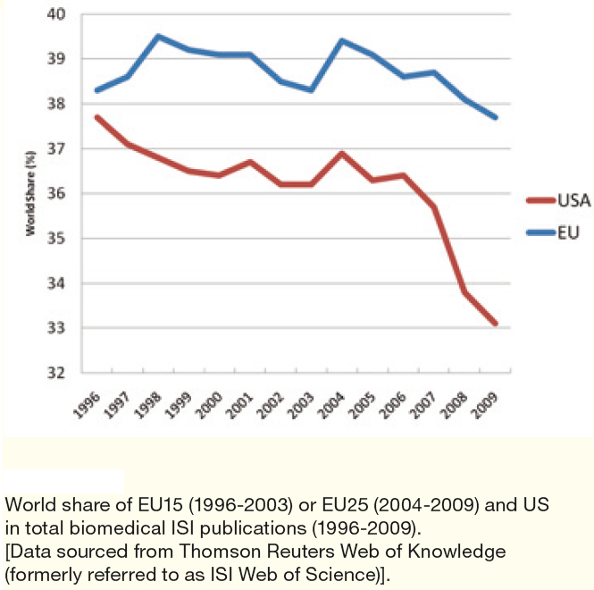
Within the European Union, based on the number of scientific publication reported in this database, United Kingdom is the most active European country for the period 2006-2010, followed by Germany, Italy and France.

Europe is well balanced in terms of specialities, albeit with greatest strength in medical research. In Europe, eight out of the top ten sub-disciplines in which the EU produces 35-40% of the world publications are in biomedical research.

Figure 10. Scientific publications reported in PubMed database for different European countries from 2006 to 2010

Source: EU-LAC (2012)

The share of European biomedical publications of all worldwide biomedical publications has remained fairly stable over the last 14 years while the share of US biomedical publications has dropped over the last five years. However, the world share of both the US and Europe tends to decrease – a consequence of the growing output of emerging countries like China, India and Brazil.

In conclusion, European countries published slightly more biomedical publications than the US over the last 14 years, but the number of citations of US publications exceeded the number of citations of European publications. All citation analyses using various indicators show that although the US still has higher citation counts and rates than Europe, the gap decreased between 1996 and 2007. The European countries have progressed compared with the US as shown by the increase in the citation counts and rates for biomedical publications.

4.3 Health research systems in the European Union

Organisation and financing

Research for health in the EU Members States has diverse ways of organisation. Still they have more structure, coordination and national funding than the ones in LAC. As in LAC, Ministries of Health and of Science and Technology play a key role in organising and conducting research.

Countries have also Medical Research Councils or Academies of Sciences that can have different roles; these could be as advisers to the Ministries, as funding agencies or as performers of research. In some countries there are organisations that have a dual role, they do coordinate funding and at the same time perform research.

Performs of research, such as academic institutions, universities, institutes, etc., are key producers for health research. Biomedical research and clinical research are two main streams of research that have substantial funding.

Then there are supra-national organisations, such as Science Europe, an association of European Research Funding Organisations (RFO) and Research Performing Organisations (RPO) that is based in Brussels. It works with national governments and the EC to develop a coherent and inclusive research area in Europe.

The European Medical Research Councils is the membership organisation for all the Medical Research Councils in Europe under the European Science Foundation in Strasbourg (France). It’s mission is to promote innovative medical research and its clinical application towards improved human health.

National funding for health research

In 19 out of the 27 EU Member States, the majority of funds are of generic nature. For the remaining eight countries, thematic funding is higher than generic although thematic funding does not always reflect the priorities set in strategy papers.

Countries have a variety of financing mechanisms. These are also linked to their political structure. While there is mainly central funding through the above-mentioned ministries, communities or provinces do allocate research funding as well. National budgets for research foster growth, productivity and possibilities of international cooperation.

Foundations are playing a relevant role on funding research and sometimes these are linked to private enterprises that use them as a tax bracket by supporting specific topics of their interest. There has been a transition to move from budgetary allocations for research to an open competition for funds based on excellency.

Priority setting

Research policy is defined differently across the EU Member States and various approaches (top-down, bottom-up, open consultations, advisory councils) are used in order to set research priorities in the various EU countries. Countries often use a mix of different approaches when defining their priorities and that the final decision is often taken top-down on the government level. On the other hand, some countries leave the priority setting (especially of thematic areas) to the research performers:

- Top-down approach: Centrally decided by the government or other decision-making bodies of the respective research system.
- Participatory approach: through consultations with stakeholders of the research and innovation system or even through public involvement.
- Advisory approach: Research Councils and other consultative bodies give advice on direction and priorities in research policy.
- Bottom-up approach: the research performers themselves mainly define research priorities.

When analysing the thematic priorities of all EU countries, 4 top themes shared by all EU MS can be identified:

- Biotechnology and Health
- Energy, Environment and sustainable development
- ICT, Telecommunications and Electronics
- Nanosciences/-technology and material research

5. Identification and analysis of the existing health research funding programmes

5.1 Public funding of health research in the European Union

It is important to say that given the complexities of the EU health research systems and the fact that health is primarily a national rather than a European-level responsibility, the scope of such an analysis focuses on the context where the European Union Health research priorities converge/meet.

Health research is supported by the European Union mainly through the European Commission's Directorate for Research the Directorate General SANCO (Health & Consumers), Directorate General INFSO (Information Society and Media), the Directorate Development and Cooperation (Europe Aid), and other directorates for fields including education, telecommunications, food safety and environment.

EU funding and mechanism of coordination of research

Knowledge lies at the heart of the European Union's Lisbon Strategy to become the "most dynamic competitive knowledge-based economy in the world". The 'knowledge triangle' - research, education and innovation - is a core factor in European efforts to meet the ambitious Lisbon goals. Numerous programmes, initiatives and support measures are carried out at EU level in support of knowledge.The largest international programme in the world dedicated to Science and Technology is the 7th Framework Programme for Research and Technological Development.

Seventh Framework Programme for Research and Development

FP7 is made up of 4 main blocks of activities forming 4 specific programmes: Cooperation / Ideas / Capacities / People; plus a fifth specific Programme on nuclear research.

Regarding health research, several programmes are covering directly or indirectly these activities:

- Cooperation – Health
- People – Marie Curie Actions
- Capacities – Research Infrastructures and International Cooperation
- Ideas – European Research Council (ERC)

Cooperation

The Cooperation programme supports all types of research activities carried out by different research bodies in trans-national cooperation and aims to gain or consolidate leadership in key scientific and technology areas.
This programme is sub-divided into ten distinct themes, which reflect the most important fields of knowledge and technology where research excellence is particularly important to improve Europe´s ability to address its social, economic, public health, environmental and industrial challenges of the future.

Health

During the last years the EU's commitment to health research has translated into the allocation of € 6,1 billion to this area under the 'Cooperation' theme of the Seventh Framework Programme for research and technological development (FP7), established for the period 2007 to 2013.

Figure 11 . FP7 Cooperation Programme breakdown in Euros

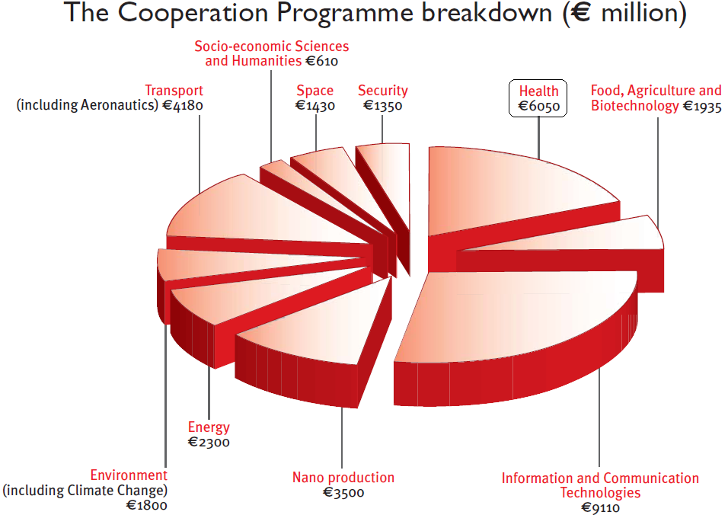

Under the Cooperation Programme, funding for Health Research is given to the following activities:
- Biotechnology, generic tools and technologies for human health, producing knowledge that will be applied in the area of health and medicine.
- Translating research for human health, making sure that basic discoveries have practical benefits and improve quality of life.
- Optimizing the delivery of health care to European citizens, ensuring that the results of biomedical research ultimately will reach citizens.
Child health, health of the ageing population and gender-related health are overarching issues of the Health theme. Translation of basic discoveries into clinical applications is one of the main objectives of this theme, clinical research is expected to be a major tool used in the funded projects.

Table 5. Budget for Health in FP7
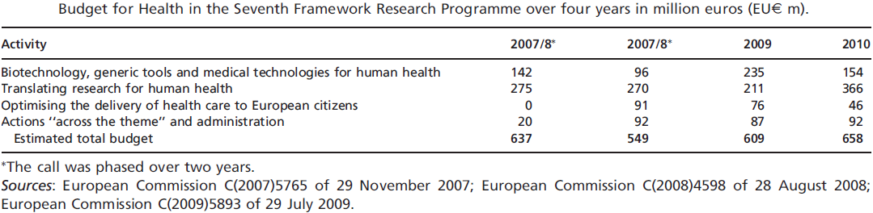

Regarding the participation of the Member States in FP7- Health Calls (from the 1st to the 5th call 2007-2010), we can extract the following relevant information showing who are the best performing countries in the Health Collaborative research programme in FP 7 (Table 6).

Table 6. FP7 Participation by country
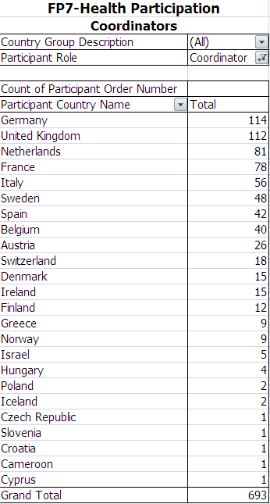
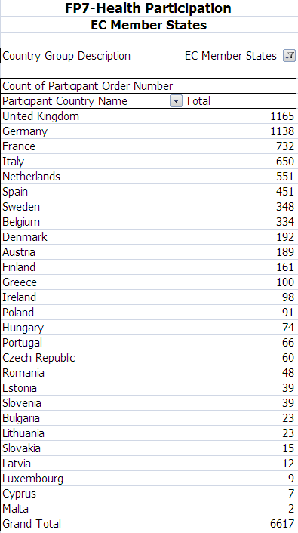

Source: EU-LAC (2012)

International Cooperation is an important aspect of FP7 and an integral part of Health. Project consortia in all areas of Theme 1 (Health) are encouraged to include organizations from International Cooperation Partner Countries (ICPC) and from countries with Scientific and Technological cooperation agreements with the EU, according to the participation rules. View the list of the International Cooperation Partner Countrie /Third Countries and consult the respective eligibility criteria. The following graph shows the best performing Third Countries in the Health theme in the first FP7 five calls. For the LAC area Brazil, Argentina and Colombia score among the first 25 countries to have succeeded in the participation.

Figure 12 .Third Countries participation in FP7, top 25 countries up to 5th call.

Source: EC, DG RTD for EU-LAC (2012)

International Cooperation in Health follows three main strategies:
- General opening of all topics to any country in the world, in which International Cooperation Partner Countries (ICPCs) can participate in projects and receive EC funding.
- Specific International Cooperation Actions (SICA), that address specific issues that partner countries face or have a global character, on the basis of mutual interest and benefit
- Programme Level Cooperation on coordinated topics with certain countries, mainly those with bilateral agreements with specific countries e.g. BRIC

Some third countries have designated National Contact Points (NCPs) for Cooperation with EU in FP7. These NCPs carry out a broad range of activities aimed at disseminating information, training, networking and facilitating cooperation among the respective scientific communities. FP7 contacts in third countries.

People – Marie Curie Actions

The People programme provides significant support for research mobility and career development, both for researchers inside the European Union and externally. It is being implemented via a coherent set of Marie Curie actions, designed to help researchers build their skills and competences throughout their careers.

The EU’s Marie Curie Actions help to fund all kinds of training and mobility opportunities for researchers by a bottom-up approach.
The 'People' Specific Programme will be implemented through actions under five headings:

- Initial Training of researchers to improve mostly young researchers' career perspectives in both public and private sectors, by broadening their scientific and generic skills.
- Life-long training to support experienced researchers in complementing or acquiring new skills and competencies or in enhancing inter/multidisciplinarity and/or intersectoral mobility.
- Industry-academia pathways and partnerships' to stimulate intersectoral mobility and increase knowledge sharing through joint research partnerships in longer term co-operation programmes between organisations from academia and industry.
- International dimension, to contribute to the life-long training and career development of EU-researchers, to attract research talent from outside Europe and to foster mutually beneficial research collaboration with research actors from outside Europe.
- Specific actions to support removing obstacles to mobility and enhancing the career perspectives of researchers in Europe.

Capacities

The Capacities programme aims to optimise the use and development of research infrastructures, while enhancing the innovative capacities of SMEs to benefit from research. The programme is designed to support regional research-driven clusters and at the same time unlock the research potential in the EU´s convergence and outermost regions. Support is to be provided for horizontal actions and measures underlining international cooperation. Finally, European society and science should be brought closer under the initiatives of the Capacities programme.

Research Infrastructures

In the scope of the Community action, the term “research infrastructures” refers to facilities that provide essential services to the scientific community for basic or applied research. Only research infrastructures which have a clear European dimension or interest are being considered. Examples include libraries, databases, biological archives, clean rooms, communication networks, synchrotrons, accelerators, and telescopes. They may be “single-sited”, “distributed”, or “virtual”.

International Cooperation³⁸

Within the capacities programme the main activities of international cooperation range from:

- Bi-regional coordination of Science and Technology cooperation: To support S&T international policy dialogue: INCO NET Projects.
- Bilateral coordination of S&T with those countries that signed S&T agreements with the Union: Bilateral projects.
- Finally, national programmes coordination and activities of Member States of the EU and Associated Countries (15) concerning international S&T cooperation: ERA net and ERA net plus.

The main projects that are being funded under this programme and that look to foster exchange and participation of EU and LA countries are presented in Table 7. Below, a brief description of these programmes is offered.

Table 7. International Cooperation Projects in FP7
Inco-Net in LAC | Starting date | Duration | Coordination | Nº Countries Involved
 |  |  |  | LAC | Europe
EULARINET* | March 2008 | 48 | Spain | 7 | 8
EUCARINET** | April 2010 | 48 | Italy | 6 | 5
ENLACE*** | November 2009 | 48 | Italy | 7 | 6
*** Enhancing scientific cooperation between EU and Central America

* EULARINET (European Union-Latin American Research and Innovation Networks is a four-year long project with the objective to strengthen the bi-regional dialogue on science and technology between Member States of the EU (Austria, France, Finland, Germany, Portugal and Spain), Associated states (Norway) and Latin America (Argentina, Brazil, Colombia, Chile, Mexico, Nicaragua and Uruguay). This includes the promotion and dissemination of FP7 activities amongst Latin American Researchers, organizing dialogue opportunities between both regions and to jointly develop work programmes for FP7.

EULARINET has produced two reports analysing how Latin America is participating in FP7. The “Mapping and recommendations for the regional policy dialogue platform”, prepared by Chile in November, 2010 (available here), reports that the challenges are to increase participation of Central American and Caribbean countries in EU funded activities, and to diversify the topics of the bilateral agreements, as they tend to follow the ones already stated in the FP7. This report also mentions that the increase of Latin America participation has been significant in the last five years analysed, and that there is more interest in bilateral agreements, as well as an increase in mobility funding and training through bilateral agreements.

**EUCARINET (European Union-Caribbean Network) is a four-year INCONET Coordination Action, supported by the European Commission (DG RTD-INCO), whose main goal is to strengthen bi-regional sustainable dialogue on Science and Technology between Europe and the Caribbean. EUCARINET targets the whole of the Caribbean region: the ACP group of states, Cuba, the Dominican Republic, Haiti, the overseas Departments and Collectivities, the Overseas Countries and Territories.

Ideas – European Research Council (ERC)

The objective of the Ideas programme is to reinforce excellence, dynamism and creativity in European research and improve the attractiveness of Europe for the best researchers from both European and third countries, as well as for industrial research investment, by providing a Europe-wide competitive funding structure, in addition to and not replacing national funding, for ‘frontier research’ executed by individual teams.

For its implementation, a European Research Council (ERC) -consisting of an independent Scientific Council and a dedicated implementation structure- has been established by the Commission under this specific programme. The ERC operates according to the principles of scientific excellence, autonomy, efficiency, transparency and accountability, and supports investigator-driven projects in ‘frontier research’, carried out by individual teams competing at the European level, within and across all fields of research.

Two types of grants are available for funding any researcher with not nationality requirements, as long as the research is carried out in EU MS or Associated Countries Institutions. Both programs are operating on a "bottom-up" basis without predetermined priorities, across all fields of research.

Health and S&T priorities and future actions

Health is not just a value in itself - it is also a driver for growth. Only a healthy population can achieve its full economic potential. The health sector is driven by innovation and a highly qualified workforce. Health-related research and development has the potential to reach 0.3% of GDP. The healthcare sector is one of the largest in the EU: it accounts for approximately 10% of the EU’s gross domestic product and employs one in ten workers, with a higher than average proportion of workers with tertiary-level education.

Health therefore plays an important role in the Europe 2020 agenda. In its communication of 29 June 2011 ‘A budget for Europe 2020’ the Commission stressed that ‘promoting good health is an integral part of the smart and inclusive growth objectives for Europe 2020. Keeping people healthy and active for longer has a positive impact on productivity and competitiveness. Innovation in healthcare helps take up the challenge of sustainability in the sector in the context of demographic change’, and action to reduce inequalities in health is important to achieve ‘inclusive growth’.

Europe’s response to a number of major global challenges will shape its future in the decades to come as stated in the Lund Declaration (2009). In the health sector, these challenges include:

- Dealing with the needs of its ageing population and the challenges of immigration;
- Preserving human and environmental health.

At the same time, European citizens expect solutions to these challenges to be found through science and technology. To address these challenges, it is imperative to:

- Bring together supply and demand-side measures to support both business development and public policy goals, e.g. the patient demands and innovative health care (research);
- Support excellence and well-networked knowledge institutions;
- Contribute to the creation and maintenance of world-class research infrastructures in Europe.

Horizon 2020

Horizon 2020 is the financial instrument implementing the Innovation Union, a Europe 2020 flagship initiative aimed at securing Europe's global competitiveness. Running from 2014 to 2020 with an € 90 billion proposed budget, the EU’s new programme for research and innovation is part of the drive to create new growth and jobs in Europe. This instrument has a strong focus on health, demographic change and faces the social and wellbeing challenges. The EU’s health of the population is the main focus in the health area.

It is expected that the adoption of Horizon 2020 will:

- Strengthen the EU’s position in science with a dedicated budget of € 24 598 million. This will provide a boost to top-level research in Europe, including an increase in funding of 77% for the very successful European Research Council (ERC).
- Strengthen industrial leadership in innovation € 17 938 million. This includes major investment in key technologies, greater access to capital and support for SMEs.
- Provide € 31 748 million to help address major concerns shared by all Europeans such as climate change, developing sustainable transport and mobility, making renewable energy more affordable, ensuring food safety and security, or coping with the challenge of an ageing population.

Trans-national collaboration in the EU

The EC is increasingly promoting the alignment of the national funding interests through some transnational instruments. Some relevant initiatives worth mentioning are:

- European Research Area Networks (ERA-NET): the ERA-NET scheme was designed to provide targeted support for the coordination and mutual opening of national and regional research programmes. It also aims at establishing long-term co-operation between national programmes, ultimately leading to joint transnational research programmes.

- Joint Programming Initiatives (JPI) are to pool national research efforts in order to make better use of Europe's public R&D resources and to tackle common European challenges more effectively in a few key areas. It follows a structured strategic process whereby Member States agree common visions and strategic research agendas to address major societal challenges. Examples of JPIs in the health area are: “Joint Programme in Neurodegenerative Diseases (JPND)”, “A Healthy diet for a Healthy life (HDHL)”, “Joint Programming Initiative in Antimicrobial Resistance” (JPIAMR) and “More Years, Better Lives – The Potential and Challenges of Demografic Change”.

- Research Infrastructures (RI) has the overall objective to optimise the use and development of the best research infrastructures existing in Europe. RI offers new possibilities for transnational coordination of research activities not only in Europe but globally. In this framework, the ESFRI (European Strategy Forum on Research Infrastructures) has the mission to support a coherent and strategy-led approach to policy-making on research infrastructures in Europe, and to facilitate multilateral initiatives leading to the better use and development of research infrastructures, at EU and international level.

- EDCTP was formed by an European Parliament and European Council decision in order to pool resources, funding and activities to achieve a greater impact against three poverty-related diseases. It combined political will and defined health priorities of both the developing and developed world. EDCTP is co-funded by the European Commission and European Member States under Article 185 (ex Article 169) of the EU Treaty to promote a more integrated approach to health research among European countries

5.2 Bilateral schemes between EU member countries and LAC countries

The schemes that are underway between the countries in both regions, contemplate that of bilateral nature between the European Union and four countries in the region: Argentina, Brazil, Chile and Mexico. The one with Colombia is underway and needs parliamentary approval. Also, bilateral cooperation agreements between individual countries have been signed in different fields.

The four countries that have the bilateral agreements with the EU have a special coordinating office within the councils or ministries of science and technology, receive Project funds, and are responsible for identifying national contact points for the different areas of interest of the current FP7, are in charge of promotion and dissemination of FP7 calls, and maintain the communication with the counterparts in the EU.

There are bilateral sessions, as well as EU-LAT meetings, as the one in Chile in March of 2012, were specific topics are brought to the agenda as to foster cooperation, to discuss topics of interest for the countries and regions as to be considered in the research agenda of the EU, and to evaluate the results of the cooperation.

Bilateral agreements can be signed between governments or by different entities, thus making it difficult to have a realistic number of agreements and topics on which these focus. There are also, inter-institutional agreements signed, these evolve from the informal cooperation until institutions want to formalise the cooperation. Given the enormous amount of research institutions in the region, the task of gathering these agreements would be impossible.

Overview of activities and bilateral agreements between the EU and LAC

We centred the efforts on the four countries that have a bilateral agreement with the EU, as these have engaged in specific tasks towards improving cooperation. A brief analysis is presented for each of the countries.

Argentina

Argentina was the first Latin American country in formalising relations with the European Union, under a third generation cooperation agreement. The Framework Agreement for Commercial and Economical cooperation entered into force in 1990. It includes as fundamental principles, the strengthening of democracy and human rights, as well as regional integration. In 1990 Argentina and the European Community sign an “Agreement on Scientific and Technological Cooperation”.

Argentina hosts in the Ministry of Science, Technology and Productive Innovation, the coordinating office of The Argentine Bureau for Enhancing Cooperation with the European Community in Science, Technology and Innovation (ABEST A-EU), established in 2005 and now working as ABEST II in cooperation with the Agency for the Promotion of the European Research , (APRE) of Italy, the Centre de Coopération Internationale en Recherche Agronomique pour le Développement, (CIRAD) of France and the Department of Science and Technology, (DST) of South Africa.

The aim of this Bureau is to establish an Argentinean platform to improve and expand cooperation activities in the science, technology and innovation area both with the European Union and with its member states. This aim will be reached by helping researchers, research institutions and local small and medium size enterprises to make a better use of present and future programmes and tools, coordinating this participation with other Latin American countries that have cooperation agreements with the European Union in science and technology (Brazil, Mexico and Chile).

Argentina has several modalities for International Cooperation: joint research projects, bilateral research centres, seminars and conferences, ST&I joint projects, and has bilateral agreements with 42 countries. Argentina has as main objective the cooperation with the MERCOSUR, and from there, to the rest of the Americas.

In promoting the EU-FP7, the Ministry of Science and Technology supported 40 dissemination seminars in the country.

Brazil

Relations between Brazil and the European Union are based on the “Framework Cooperation Agreement” signed in 1992, and on the Framework Agreement of cooperation between the European Union and The MERCOSUR”, signed in 1995. In January 2004, Brazil and the EU signed an “Agreement on Scientific and Technological Cooperation”.

The Brazilian Bureau for Enhancing the International Cooperation with the European Union (B.Bice) was created in 2005 with the intention to both promote and improve the cooperation between Brazil and the EU in Science, Technology and Innovation.

The European Commission approved the extension in October 2008, now called BB.Bice, for a further three years period. Amongst the stated activities it includes the development of a Competency Map of the Brazilian Institutions towards helping the expansion and knowledge of the Brazilian competencies in the European Union.

Chile

The specific EU-Chile office was opened in 2005. Its mission is to increase Chilean participation in EU funded projects, and acts as the focal point to the bilateral agreement signed in 2002.
The National Commission of Scientific and Technological Research, form Chile (CONICYT), through the liaison office, does participate in three other FP7 funded projects: two multilateral (EULARINET and Biocircle2) and one bi-regional (CHIEPII).
CHIEPII intends to maximize cooperation in Science & Technology and Innovation between the European Community and Chile, supporting the incorporation of the Chilean scientific and technological community into the Seventh Framework Programme (2007 to 2013).
The International Relations Department in CONICYT supported a total of 74 new projects of bilateral exchange with Brazil, Argentina, Colombia, Spain, Mexico, France and Germany, and seven new projects of multilateral networks with CYTED and others, and five projects with centres of excellence. The total amount of cooperative funds with these projects and networks is of over 46 million Euros.
CONICYT has signed agreements with 14 European countries in different topics; France is the country with most agreements signed on specific topics.

Mexico

Bilateral relations between the EU and Mexico are ruled by the “Association Agreement for Economic, Political concertation and cooperation” signed in December 1997. The bilateral “Agreement for Scientific and Technological Cooperation” was signed in February 2004.

Mexico coordinating entity with the EU is the Office for the European Union-Mexico for Science and Technology (UEMEXCYT2), funded jointly by the National Council of Science and Technology and the EU. It has the intention to both promote and improve the cooperation between Mexico and the EU in Science, Technology and Innovation, as well as acting as the focal point for all FP7 actions.

This office, along with CONACyT, coordinates the Fund for international Cooperation in Science and technology between Mexico and the European Union (FONCICYT), a joint € 20 million investment to finance research projects. This fund was launched in 2008, the expression of interest brought over 900 proposals, of which 317 had the needed elements for completion of the requested proposals. Rules were that 2 Mexican and 2 European institutions had to be part of the consortium, 70% of the proposed budget for the project to be covered by the program, and quality and pertinence would be the evaluating factors. 218 consortia proposals were received with an overall amount of funding requested of 143 million Euros.
The funding from the EU to Mexico through FP7 projects, up to mid year of 2011, was of the amount of close to € 100 million Euro for all type of coordinating actions, and financing, in four projects that started between 2008 and 2010, the Health area received close to €14 million.
Mexico and Brazil launched in 2011 a joint call for bilateral collaboration in nanotechnology, and Mexico-France with the French National Research Agency and OSEO and/or Mexico-Spain with the Centre for Industrial Technological Development also launched a bilateral call for the area of biotechnology, health and other topics. CONACYT has bilateral agreements with almost all countries in the region. CONACYT offers a specific website (http://www.pcti.gob.mx/) for international cooperation.

LAC participants in FP7 funded projects

The LAC region has been active in submitting and participating in FP7 projects. According to data from CORDIS, overall in all areas, LAC has had participation in 456 projects that amount 69.12 million Euros from the beginning of FP7 to 2011. (Table 8)

Brazil leads the region with a total of 125 projects in which they participate (33.87%) followed by Argentina (14.93%), Mexico (11.63) and Chile (6.71%).

In health-funded projects in FP7, LAC countries participate in 72 projects (15.8%) of the total projects funded by the EC. The amount received through the health projects is of 14.58 Million Euros, equivalent to 21.1% of all funds received. (Table 9)

Only 16 countries participate in health projects, and Brazil leads the group with 20 projects and 4.3 million Euros, followed by Argentina with 11 projects and 2.37 million Euros. Colombia is in third pace with nine projects and 1.96 mill €, followed by Mexico with five projects with 0.85 mill €.

Bolivia, Chile, Peru each has four projects, while Uruguay and Ecuador have three, Costa Rica and Nicaragua two each, and Cuba, El Salvador, Guatemala, Haiti and Venezuela one.

Table 8. Participation of LAC Countries in FP7 funded projects

LAC COUNTRIES PROFILE - EC FP7
Country | EC Contribution to FP7 Grant Holders in Million EUR | Signed Grants | % LAC Countries
Argentina | 10.32 | 76 | 14.93
Bolivia | 2 | 11 | 2.89
Brazil | 23.41 | 125 | 33.87
Chile | 4.64 | 40 | 6.71
Colombia | 4.1 | 32 | 5.93
Costa Rica | 3.41 | 18 | 4.93
Cuba | 0.21 | 5 | 0.30
Dominican Rep. | 0.19 | 2 | 0.27
Ecuador | 2.3 | 14 | 3.33
El Salvador | 0.17 | 1 | 0.25
Guatemala | 0.64 | 4 | 0.93
Guyana | 0.7 | 3 | 1.01
Haiti | 0.09 | 2 | 0.13
Honduras | 0.37 | 3 | 0.54
Jamaica | 1.37 | 6 | 1.98
Mexico | 8.04 | 59 | 11.63
Nicaragua | 0.75 | 4 | 1.09
Panama | 0.47 | 5 | 0.68
Peru | 2.7 | 16 | 3.91
Suriname | 0.13 | 1 | 0.19
Trinidad and Tobago | 0.06 | 1 | 0.09
Uruguay | 2.65 | 24 | 3.83
Venezuela | 0.4 | 4 | 0.58
LAC | 69.12 | 456 | 100
Source: Generated with CORDIS data

Table 9. Countries with FP7 projects in Health
Country | Health
 | Number of Grant Holders | EC Contribution (EUR million)
Cuba | 1 | 0.11
El Salvador | 1 | 0.17
Guatemala | 1 | 0.21
Haiti | 1 | 0.02
Venezuela | 1 | 0.21
Costa Rica | 2 | 0.34
Nicaragua | 2 | 0.57
Ecuador | 3 | 0.73
Uruguay | 3 | 0.44
Bolivia | 4 | 0.79
Chile | 4 | 0.41
Peru | 4 | 1.1
Mexico | 5 | 0.85
Colombia | 9 | 1.96
Argentina | 11 | 2.37
Brazil | 20 | 4.3
LAC | 72 | 14.58
Source: Generated with CORDIS data

Other Bi-regional funding initiatives

CYTED

The Ibero-American Program of Science and Technology for Development (CYTED) was created in 1984 through an inter-institutional agreement signed by 19 countries of Latin America, Spain and Portugal.
CYTED has the objective to contribute to the harmonic development of the region through cooperation mechanisms between research groups of the universities, research centres and innovation companies of the Ibero-American countries towards the achievement of scientific results that are transferred to productive systems and social policy.
Through its existence, CYTED has generated 210 thematic networks, 197 coordinating actions, 4 research consortia, and 33 innovation projects with an annual participation of over 10,000 scientists.

Specifically in health, and since its origin, CYTED has approved 45 networks where over 1070 research groups of Ibero-America have participated with an estimated 4,100 researchers involved. The mean life of a network is four years, and the estimated funding is around €5.9 million.

Spain has coordinated 14 networks, Brazil 6, Colombia 5, Argentina and Uruguay 4, Cuba 3, Mexico2, and Portugal, Costa Rica and Panama 1 each. Regarding the consortia in health research, 17 projects have been financed (Spain 5, Argentina 3, Brazil 2, and Chile, Bolivia, Colombia and Mexico 1) with an estimated total amount of €13.6 million. Topics cover basic research as well as public health research. The program doesn’t finance clinical trials.

European research centres in LAC

The Institute Pasteur is based in Montevideo, Uruguay, and established there in 2004 by a joint agreement between the governments of France and Uruguay and the Institute Pasteur of Paris.

Considering Germany’s support, there are the Dallmann-Laboratory/Argentina, Pierre-Auger-Observatory/Argentina and quite some with biomedical focus like Max-Planck-Partner-Institute for biomedical research in Buenos Aires, Heidelberg Centre in Santiago de Chile, CETA-RS/Brazilian, Fraunhofer Chile – Centre for Systems Biotechnology (under construction), as examples of the interest of European Countries to work in the region.

Bilateral agreements

Countries in the LAC region have several bilateral agreements signed with European countries. The Ministries of Health or the Ministries or Councils of Science and Technology have signed these agreements. Some details are shown in the specific report for Task 1.2. What is not clear, is the use of these agreements, and if these have been implemented or taken advantage of.

The agreements do cover a wide array of actions, and sometimes the bilateral academic support (fellowships, etc.) is part of these agreements. Ministries of S&T are more active to promote the signing of agreements.

Interaction between EU-LAC policies for Aid Development and Health Research cooperation
Scientific knowledge and Innovation has been considered a relevant instrument for aid development because of its capacity to provide effective innovation to combat main challenges in global health.
In the same way, strategies for cooperation for development that were agreed in Paris and Accra are essential to improve the effectiveness and impact in research for health.
The main legal document governing the European Community Cooperation with other world’s regions is the Development Cooperation Instrument (DCI). Under the framework of DCI, Regional Programming for EU-LAC Development Cooperation 2007-2013 (RSP) lays down strategic priorities: multilateralism, social cohesion and regional integration.
The EU (MS plus EC) is currently the main donor in the LAC region, ahead of the United States, with an important contribution estimated at an average of 450 million Euro/ year.
EC Aid Development Policy is said to focus primarily in the education vertex of the called “knowledge triangle” in detriment of innovation or research, while its value is explicitly recognized as a crosscutting objective for sustainable development, social cohesion and combating poverty.
National Cooperation Aid Agencies (NCA) develop a leading role as far as global health research is referred. The recipients of the projects funded by NCA are mostly either Multilateral Public Agencies or Private Platform for Medical Product Developments (PDP).
The main European agencies of cooperation involved on health research development projects are: NORAD, SIDA, DFID, DANIDA, BMZ/GIZ, AECID, and Irish Aid. As an important Philanthropic European based organizations, The Wellcome Trust, Foundation Meraux, and UBS Optimus Foundation should be mentioned.

Trans-national cooperation in the LAC region

The region has experienced a growth in trans-national cooperation. There are networks that are engaged with research and research for health. Amongst these, we can mention the Ibero-American Ministerial Network for Learning and Research in Health (RIMAIS) that has 18 members, two of these being Spain and Portugal. The network is currently working in building capacities for research for health managers through a project funded by the Spanish Agency for International Cooperation and Development (AECID). Members are also involved with a project funded by CYTED with the objectives to measure research development in the region.

There is a good experience with the network on health systems research with the participation of Argentina, Brazil, Paraguay and Uruguay, and with the coordinating support by the International Development Research Centre (IDRC), from Canada. Relevant to mention too, is the experience with Santa Catarina & Fiocruz on social protection (multinational).

The Evidence Informed Policy Network (EVIPNet), a WHO initiative, has gained strength in the LAC region under the support of PAHO. Trans-national workshops have been successful in training professionals on writing policy briefs, and in the use of research evidence for policy making.

The Cochrane collaboration has a strong presence in the region. As part of the Ibero-American Cochrane centre, based in Barcelona, there are three branches in the Latin American Region, the Central America and Spanish Caribbean, based in Costa Rica, The Andean Branch based in Venezuela, and the South American Branch, based in Argentina/Chile. Brazil has a country centre based in Sao Paulo.

The Network on Research and Training in Tropical Diseases in Central America (NeTropica) brings skills and organized multinational collaboration in biomedical research. This network gives complementary grant funds to Central American and Swedish laboratories participating in joint research activities, supports the organization of scientific meetings and courses, promotes the exchange of scientists and distributes relevant information for fundraising and collaborative research among the network participants that is formed by the Central American countries.

The Latin American and Caribbean Information centre on Health Sciences (BIREME), was established in 1967, and is based in Brazil, is the main LAC information centre on health sciences and is oriented to upgrade technical cooperation and scientific information on health. It runs under an agreement between PAHO and the Government of Brazil.

5.3 LAC regional and sub regional organisations

The Latin American and Caribbean regions host a wide variety of regional and sub-regional organisations. The Americas saw the first regional health organisation in the world, the Pan-American Sanitary Bureau in 1902, as well as the oldest regional organisation, the Organisation of American States (OAS). These efforts of unity, more than a century ago, have changed along the years.

Differently than Europe that have gained unity through a common market and political union through the European Union, the LAC region due to its size, the geographical sub-regions and the political changes and leaderships have open space to an interesting array of organisations seeking in general for the same objective of equity and human development of the population.

This fragmentation has not allowed for one single entity with wide representation as the European Commission and its’ different bodies. The investment in science and technology is more the responsibility of the countries than the region as a whole. Differences in investments in R&D vary as it was shown before.

Organization of American States
  - Headquarters, Washington, DC, USA

The Organization of American States (OAS) is the world’s oldest regional organization, created during the First International Conference of American States, held in Washington, D.C., in 1890. That meeting approved the establishment of the International Union of the American Republics.
Today, the OAS brings together all 35 independent states of the Americas and constitutes the main political, juridical, and social governmental forum in the Hemisphere. In addition, it has granted permanent observer status to 67 states, as well as to the European Union (EU).
The Organization recognizes the role of the Pan-American Health Organisation as the leading partner in health related matters.

Pan-American Health Organization/World Health Organisation
  - Headquarters, Washington, DC, USA

The Pan-American Sanitary Bureau was established in 1902 by the Second International Conference of American States. Later on, after the World Health Organisation (WHO) was created, it also became the Pan American Health Organization (PAHO) as the inter-American system’s specialized organization in all health related matters and the World Health Organization’s Regional Office for the Americas (AMRO/WHO). Its mission is to “lead strategic collaborative efforts among member states and other partners to promote equity in health, to combat disease, and to improve the quality of and lengthen the lives of the peoples of the Americas.”

PAHO has a specific area that deals with research, and is the Research Promotion and Development Unit. Its program focuses on the strengthening of research for health through the dissemination and translation of knowledge, the promotion of research governance, and the monitoring of ethics and standards within research practices. PAHO has joined forces with COHRED in developing the platform Heath Research Web/Americas (HRWeb, www.healthresearchweb.org), an interactive platform that facilitates access to key information on the national research for health systems in the world, becoming a growing source of information on research for health systems.

PAHO has an Advisory Committee for Health Research (ACHR) that evaluates and suggests strategies to the Organisation on issues related to research for health. It has been recently revitalised and was key in suggesting to the Organisation to move ahead on developing an approved Regional Policy on Research for Health. However, PAHO doesn’t finance any research except the ones inside the organisation.

Ministers’ of Health Council of Central America (COMISCA)
  - Headquarters: El Salvador

The Ministers’ of Health Council of Central America and the Dominican Republic (COMISCA) is the political instance of the Central American Integration System (SICA) that has as a purpose the identification, approach and solution of regional health issues that are dealt with in accordance to the Agenda and Mesoamerican Health Plan.
Recently COMISCA has taken steps towards strengthening of research for health, as it has been mandated to establish a regional research commission and to analyse further steps to support countries for their own development.

Andean Health Organism, Hipolito Unanue Treaty
  - Headquarters, Peru

As a sub-regional integration organization, they belong to the Andean Integration System whose objective is to coordinate and support efforts of the member states, individually or collectively, for the improvement of health of their populations.
The main action lines defined by the Minsters of Health are, for the Axis: Health integration, the following areas of work. Area: Epidemiological Shield, Area: Access to Medications, Area: Human Resources, Area: Social Determinants of Health, Area: Universal Health Systems.

Amazon Cooperation Treaty Organization (ACTO),
  - Headquarters, Brazil

Science and Technology
The aims and objectives of the Coordinating Office of Science, Technology and Education are part of the thematic approach of the Knowledge Management and Information Sharing for the Amazon. Due to the crosscutting features of its activity, this Office’s functions extend to the various science and technology activities existing in other Coordinating Offices.
Health Coordination
The New Cooperation Strategic Agenda sets up priority areas for the Regional Management of Health. Amongst the, there is a recent addition: strengthening and consolidation of research in the Amazon.
ACTO is part of the Coordinating Committee of the South American Council of Health. In this context and as part of the mandate, the priority areas of the AECA are to be articulated with the guidelines of the South American Council of Health 2010-2015 Five-Year Plan.

South American Nations Union (UNASUR)
  - Headquarters, Ecuador

The political sub-regional union UNASUR, has two main issues related to Science and Technology (S&T). One is the Andean Community’s new Common Industrial Property System that started on December 1st, 2000. Countries grant more protection in term of patents, trademarks and control of exchange of goods.
The other is the Intellectual property and authors’ copyrights, providing protection to authors and descendants on copyrights. Countries are obliged to protect the original author and cessed all intents of violation.

The Caribbean Community (CARICOM)
  - Headquarters, Guyana

The transformation of the Caribbean Free Trade Association (CARIFTA) in 1972 into a Common Market brought to life the actual CARICOM. The objectives of the Organisation are: to improve standards of living and work; the full employment of labour and other factors of production; accelerated, coordinated and sustained economic development and convergence; expansion of trade and economic relations with third States.

Caribbean Health Research Council (CHRC)
  - Headquarters, Trinidad & Tobago

The Caribbean Health Research Council (CHRC) is the regional institution with the mandate to promote and coordinate health research in the Caribbean. It serves countries that are members of the Caribbean Community (CARICOM), providing advice to their Ministries of Health and other stakeholders and generally supporting research related activities.
Formed in 1955, the Council held its first scientific meeting in Jamaica in 1956, and they will be having their 57th meeting in 2012. Over the years, there has been a broadening of the membership to include Caribbean countries that were not a part of the British Commonwealth, such as Suriname and Guiana.
This body has been actively promoting and financing research for health in the sub-region, was first in having a Policy on Research for Health, and has integrated a Prioritised Research Agenda for the Caribbean.
The Caribbean Public Health Agency (CARPHA)

The decision to establish the Caribbean Public Health Agency (CARPHA) was confirmed by the CARICOM Heads of Government in March 2010. The Agency is currently in a set-up phase. Leadership for this new regional health organization is expected to be recruited during the last quarter of 2011 / first quarter of 2012. An implementation team will also be recruited then. That team will oversee the smooth implementation of this new organization.

Southern Common Market (MERCOSUR)
  - Headquarters, Uruguay

Integrated in 1991 by Argentina, Brazil, Paraguay and Uruguay, countries that share common values for development and democracy, security, and social justice. It started as a political and commercial treaty that has expanded to many working groups, health amongst them. Later on, Bolivia, Chile, Colombia, Ecuador, Peru and Venezuela have joined as associated countries.
The Health Secretariat has three commissions: health products, health services provision, and health surveillance. MERCOSUR has also three commissions under the specialized meeting on S&T. Support for scientific and technological development, informatics society, and the Biotechnology Platform of the South.

Inter-American Development Bank (IDB)
  - Headquarters, Washington, DC

The Bank supports efforts by Latin America and the Caribbean countries to reduce poverty and inequality. They aim is to bring development in a sustainable way. So far it is the largest source of development financing for Latin America and the Caribbean, having a strong commitment to achieve measurable results. The Bank, besides tending loans, also provides grants, technical assistance and supports some operative and evaluation research.

Health/IDB
This section for the bank has loaned small grants/loans for social projects of up to US10 mill/year, as an example, the Mesoamerica 2015 initiative has been supported. Health section has no funds for operative research. As the interest on Latin America is decreasing, funds are diminishing and this could cause a social and health issue on the future in the region. (Information through personal communication, Mr F Regalia, IDB Washington)

Innovation, Science and Technology
This section of the IDB has loaned funds for ministries of Education and Science and Technology. Many of these funds have been used to finance calls for research proposals through Ministries and Councils of Science and Technology. Of the countries mentioned, are Argentina, Brazil, Colombia, El Salvador, and Paraguay. One area that is bringing attention and increasing funding is climate change.

Some of the latest projects and topics that have been financed by the Bank are presented in Table 10. The range of amount goes from close to two million US Dollars, up to 100 million US Dollars, some are loans and others are non-reimbursable funds. To see the individual characteristics, please click on the link on each project’s name.

Table 10. Examples of recent projects in S&T financed through IDB*
COUNTRY | NAME | APPROVAL DATE
Peru | Innovation Project for Competitiveness | Jan 12, 2012
Chile | Intellectual Property for Development: Access & Diffusion of registered knowledge | Nov 29, 2011
Argentina | Technological Innovation Program II | Nov 1, 2010
Mexico | Regional Innovation Systems in Mexico | Aug 30, 2010
Regional | Cooperation System on operational Information and Industrial Property | Dec 1, 2009
Argentina | CCLIP: Program of Technological Innovation | Sep 2, 2009
Regional | Entrepreneurship and Technological Innovation Regional Program | Dec 9, 2008
Uruguay | Technology Development Program II | Jul 30, 2008
Panama | Multiphase Technological Transformation Program-PhaseI | May 22, 2008
Source: http://www.iadb.org/en/projects

6. Conclusions

From LAC countries, Argentina, Brazil, Chile and Mexico, lead scientific production, investment of S&T as percentage of GDP, patents, etc. From these, Brazil leads in all fields and is located amongst the main countries in the world. These four countries are the only ones with a bilateral agreement with the EU, thus benefiting from special funding through FP6 and FP7 to run the coordinating offices for the work with the EU in their countries.

Colombia and Panama are making important investments in the sector and have innovating policies. However those countries with no plans for changes or investments in S&T may be left behind and the gap may become broader and the difficulties to overcome it may be greater.

In the Caribbean, the role of the Caribbean Health Research Council (CHRC) has been crucial as to maintain research for health in the region, but having a policy and a prioritised research agenda are not enough, the CHRC needs to increase its funding as to be able to finance the research agenda. The Council could gear into a more collaborative research if having the funds to interest multicentre research.

The variety of agencies and organisations in the LAC region may cause fragmentation of efforts and funding towards an efficient work. However, most regional Multilateral Organizations in Latin America and the Caribbean have developed programs to promote scientific and technical cooperation. We must say that they have all expressed an active interest in increasing cooperation with the EU Framework Programme.

The existence of networks that promote collaboration and coordination has proven to be a good way to foster transnational cooperation. Countries should take advantage of these partnerships and guide the role of international organizations in providing a shared framework and bringing partners to the table.

Collaboration with the EU has increased in the region and this is a reflection of the continuous efforts taken by the EU towards engaging with the countries in the region. This is shown by the amount of projects countries in the LAC region are involved in.

The efforts that the EU is devoting to promote funding programmes and to enhance research in the region are very important. Benefits are there for all interested parties, and a greater participation of LAC institutions and researchers can be achieved.

During the last decade, most of Latin American countries have been making important investments and advances in health research. These investments are reflected in the strengthening and development of their National Health Research Systems (NHRS), with noticeable results in scientific and technological progress in the region.

Although the number of countries that stand out in this direction is still limited and the situation is very different among the various countries, there has been a solid momentum towards developing and/or consolidating necessary elements for the concretization of National Health Research Systems over the last 10-12 years.

More than 60% of the 13 questionnaires received showed countries with a formal governance body dedicated to health research, specific policies and a plan of priorities for research in health defined in participatory processes. Most countries have laws / regulations for clinical studies, ethical standards for research and product registration.

Most of the financing comes from the government and mainly through S&T agencies. Health financing mechanisms as well as agencies are growing in importance, but apart from Brazil, this growth has been slow. In many small / poor countries, most of the financing comes from abroad.

Public universities are the main actors in health research execution. Specialized institutes of the ministries of health also play a very important role.

The European Union is characterized by a heavily diversified R&D investment in Health. Each Member State dedicates a different percentage of GDP in R&D and in Heath R&D; often there is a differentiation in the duration of the strategies put in place by the governments as well as in the selected Health research priorities.

The EU FP 7 programme is a huge opportunity and the highest financial source for the European and International R&D, as well as the unique model agreed by the Member States and Associated Countries to set some common Research and Innovation priorities around which to structure and enhance EU competitiveness and progress.

The EU through FP7, unlike previous Framework Programmes, provides a new approach to its scientific and technological research policy by introducing international cooperation as an essential strategy in each of their specific programs giving the possibility of joint initiatives among European institutions and Third Countries.

EU-LAC bilateral relations have already come a long way, however the effective incorporation of Spain and Portugal to the EU in 1986 meant a decisive boost to the cooperation and not only on the commercial side. The European Commissions Communication: “The European Union and Latin America: Global Players in Partnership” proposed to establish a permanent dialogue in S&T to make progress in developing a EU-LAC Knowledge Area.

Bibliography

DE LOS RIOS, R., 1999. La promoción de la investigación en salud pública: búsqueda del equilibrio entre pertinencia y excelencia. Revista Panamericana de Salud Publica, 5: 4-5. Available at: http://www.scielosp.org/scielo.php?pid=S1020-49891999000400021&script=sci_arttext&tlng=pt)

ECOSOC, 2011. Challenges for education with equity in Latin America and the Caribbean. Regional Preparatory Meeting 2011. Buenos Aires, Argentina, may 12-13, 2011.

OECD, 2002. The Measurement of Scientific and Technological Activities. Frascati Manual: Proposed Standard Practice for Surveys on Research and Experimental Development.

OECD, 2005. Glossary of Statistical Terms. Available at: www.oecd.org.

UNESCO, 2010. UNESCO Science Report 2010. Available at: http://www.unesco.org/new/en/natural-sciences/science-technology/prospective-studies/unesco-science-report/unesco-science-report-2010/

WHO, 1981. Executive Board Meeting EB67/PC/WP/4.

Europe 2020: “A strategy, for smart, sustainable and inclusive growth”. COM (2010) 2020 Final. Brussels 3.3.2010
All information regarding SOM EU LAC meetings can be seen at EC Research/ International Cooperation/ Policy Framework Webpage
http://ec.europa.eu/research/iscp/index.cfm?lg=en&pg=latin-americ-carib-2
State of Health in Latin America and Caribbean countries: Burden of disease and Research and Response Research. Tomas López-Peña Ordóñez. July 2008
CEPAL data, Anuario 2011
ECLAC, 2011. Statistical Yearbook for Latin America and the Caribbean. Available at: http://www.cepal.org/publicaciones/xml/8/45608/LCG2513b_notas.pdf
RICYT.http://bd.ricyt.org/explorer.php/query/submit?excel=on&indicators%5B%5D=GASPBI&syear=1990&eyear=2009&
UNESCO, 2010.
The patents filed at the USPTO are considered to be of high quality.
UNESCO, 2010.
http://www.scimagojr.com/
Agenda 2011. Temas de Indicadores de Ciencia y Tecnología, RICYT, http://www.ricyt.org/
Pang T, Sadana R, Hanney S, Bhutta ZA, Hyder AA, et al: Knowledge for better health - A conceptual framework and foundation for health research systems. Bull World Health Organ 2003, 81:815-820.
Report on the 1st Conference on Research and Innovation for Health, 2008, Executive Committee. Available at: http://www.cohred.org/healthresearchlatinamerica/
http://ec.europa.eu/regional_policy/sources/docgener/presenta/projectbook/project_book_02_research_en.pdf
Monitoring Financial Flows for Health Research 2009. Global Forum for Health Research 2009
European Medical Research Councils (EMRC), White Paper II, A Stronger Biomedical Research for a Better European Future: http://www.esf.org/uploads/media/emrc_wpII.pdf
http://epp.eurostat.ec.europa.eu/cache/ITY_OFFPUB/KS-EP-08-001/EN/KS-EP-08-001-EN.PDF
EMRC, White Paper II, A Stronger Biomedical Research for a Better European Future
Global Forum for Health Research. (2009). Monitoring Financial Flows for Health Research 2009 Behind the Global Numbers. (Edited by Erik Landriault and Stephen A Matlin).[Link]
The World Bank Country Classification for 2008 lists 43 countries as ‘low income’ (GNI per capita US$ 975 or less), 55 ‘lower middle income’ (US$ 976 to 3855), and 46 ‘upper middle income’ (US$ 3856 to 11 905). http://data.worldbank.org/about/country-classifications http://www.mcc.gov/documents/data/data-fy12-selection-lmic-dataset.xlsx
NABS: Nomenclature for the Analysis and Comparison of Scientific Programmes and Budgets, Further information available at http://www.oecd.org/dataoecd/62/38/43299905.pdf.
Emmanuel Hassan, Susan Ella Kirk (2009) Is there a European Medical Research Area? Observatory on Health Research Systems Prepared as part of RAND Europe’s Health Research System Observatory Documented Briefing series supported by the Department of Health (England)
European Medical Research Councils (EMRC), White Paper II, A Stronger Biomedical Research for a Better European Future: http://www.esf.org/uploads/media/emrc_wpII.pdf
http://www.ncbi.nlm.nih.gov/sites/entrez
Conceição and McCarthy Health Research Policy and Systems 2011, 9:38 http://www.health-policy-systems.com/content/9/1/38
http://www.scienceeurope.org/
http://www.esf.org/research-areas/medical-sciences.html
BILAT-USA Task 2.1 Milestone 3 (2010). Analysis of Science &Technologies Priorities in Public Research in Europe and the United States of America [Link].
http://cordis.europa.eu/fp7/who_en.html#countries
http://ec.europa.eu/health/index_en.htm
http://ec.europa.eu/dgs/information_society/index_en.htm
http://cordis.europa.eu/fp7/health/
ttp://bookshop.europa.eu/en/european-research-for-a-healthier-future-pbKI7809688/downloads/KI-78-09-688-EN-C/KI7809688ENC_002.pdf?FileName=KI7809688ENC_002.pdf&SKU=KI7809688ENC_PDF&CatalogueNumber=KI-78-09-688-EN-C
Overall review of EU Member States and Associated countries ( Innovation Union Competitiveness Report 2011)
http://cordis.europa.eu/fp7/who_en.html#countries
http://cordis.europa.eu/fp7/who_en.html#countries
http://cordis.europa.eu/fp7/health/third-countries_en.html
http://cordis.europa.eu/fp7/mariecurieactions/
Quick-Guide to the Marie Curie Actions: http://cordis.europa.eu/fp7/mariecurieactions/guide_en.html
http://cordis.europa.eu/fp7/people/initial-training_en.html
http://cordis.europa.eu/fp7/people/life-long-training_en.html
http://cordis.europa.eu/fp7/people/industry-academia_en.html
http://cordis.europa.eu/fp7/people/international-dimension_en.html
http://cordis.europa.eu/fp7/people/specific-actions_en.html
http://cordis.europa.eu/fp7/capacities/research-infrastructures_en.html ³⁸http://cordis.europa.eu/fp7/capacities/international-cooperation_en.html
The European Research Council in a nutshell: http://erc.europa.eu/sites/default/files/press_release/files/erc_in_a_nutshell.pdf
http://ec.europa.eu/research/horizon2020
UEMEXCYT Office database, shared by Ms Rita Torres-Pascacio
http://www.conacyt.gob.mx/CooperacionTecnologicaBilateral/Documentos_2011/Convocatoria_Mexico-Brasil_2011.pdf
http://www.pcti.gob.mx/es-es/bilaterales/Paginas/ConvocatoriasBilaterales.aspx
LAC Countries profiles, EC FP7
http://www.cyted.org/cyted_informacion/es/presentacion.php
Fuente: Intranet Programa CYTED
Paris Declaration (2005), Accra Agenda for Action (AAA, 2008)
Launched in January 2007, the Development Co-operation Instrument (DCI) replaces a wide range of geographic and thematic instruments which was created over time.
http://www.iadb.org/en/projects/advanced-search,1301.html?query=&ProjectNumber=&Status=APP&Country=&Topic=SCTE&Sector=CT&SubSector=&Fund=&Cofinancing=&FinancialProd=&ProjectType=&YearFrom=2008&YearTo=2012&FinancingOver=750000&FinancingUnder=500000000&FinCurrency=USD&adv=true

